­

Cooking with Splunk and AWS

Splunk Add-on for AWS 4.3+ and App 5.1+

Kamilo Amir

Table of Contents

Cooking with Splunk and AWS Lab Overview 4

Purpose 4

Prerequisites 4

Workshop Agenda 4

Module 1 – Getting Started with AWS 6

Module 2 – Configure AWS 7

Admin Account 7

Create Splunk Access IAM Policy 11

Create EC2 Role 13

Setup AWS Config 18

Set up AWS CloudTrail 25

Module 3 – Setting up Splunk Infrastructure 37

Splunk Cloud Sales Trial 37

Amazon Image (AMI) Marketplace 37

Install Splunk App and Add-on for AWS 42

Setup Splunk HTTP Event Collector (HEC) 44

Setup Lambda Function 46

Module 4 – Setting up Splunk App for AWS 51

Adding SplunkAccess User 51

Adding SplunkEC2Role 52

Setting up AWS Config in Splunk 53

Setting up AWS Config Rules in Splunk 54

Setting up AWS CloudWatch (metrics) in Splunk 55

Setting up AWS CloudTrail in Splunk 56

Setting up AWS Inspector in Splunk 57

Setting up AWS Description (metadata) in Splunk 58

Setting up AWS Billing in Splunk 59

Module 9 – Setting up Kinesis Firehose 60

Module 5 - Troubleshooting 61

Summary 62

Data Collection Estimates 62

Breakdown of Data Volumes by sourcetype in AWS 62

Appendix 63

Splunk Access Account 63

# Cooking with Splunk and AWS Lab Overview

## Purpose

The purpose of the Cooking with Splunk and AWS Lab is to help teach people about AWS services and how to connect them to their Splunk deployment. The structure of this lab is as follows:

## Prerequisites

In order to participate in this class you must have: 1) a working AWS Account in good standing, 2) Full Admin rights to the AWS Account 3) Completed at least SE II Splunk training.

## Workshop Agenda

|  |  |
| --- | --- |
| Demo URL | [Demo of Splunk App for AWS](http://awsdemo.splunk.com/) |
| Overview | [Workshop Overview Module](https://drive.google.com/file/d/13QLyqCGQyIYHGsRouTI8zFCVT4bYM4-9/view?usp=sharing) |
| Pre-Work | [Module 1 – Getting Started with AWS](https://drive.google.com/file/d/13yiJySY8TkvLLQ1tJ06BSBV_gLOrPJuL/view?usp=sharing) |
| AWS Workshop | [Module 2 – Configure AWS](https://drive.google.com/file/d/13g1EPdNupvkDT3__O5N2zmsfVNwa9DZb/view?usp=sharing)  [Module 3 – Setting up Splunk Infrastructure](https://drive.google.com/file/d/14jR2ucKPnvaH88i7ZNHvn8HTkF0EaKYH/view?usp=sharing)  [Module 4 – Setting up Splunk App for AWS and Add-on](https://drive.google.com/file/d/14FVWYmrK_saeEZkG4Lt5RTrso8tDUlCR/view?usp=sharing)  [Module 5 – Troubleshooting App](https://drive.google.com/file/d/13QCOBJHGCC1ebuCpy8t2m4DcaKiY81iS/view?usp=sharing) |
| AWS Lab Guide | [AWS Workshop Lab Guide](https://drive.google.com/file/d/13lOba5f9GAV9JvvnVuIc2UW0MSubPUDv/view?usp=sharing) |
| GDI and AWS Sizing | [Module 11 - Sizing AWS Environment](https://drive.google.com/file/d/11t7gLBPX9ejEgc-3SEFPbli6eC977fxy/view?usp=sharing) |
| Video of AWS Setup | [Setup AWS Video Recording](https://drive.google.com/file/d/1OsGm770_Yq70ogVPgnFR0WgCsNS5eKLy/view?usp=sharing) |

Additional Reference Material

|  |  |
| --- | --- |
| CloudFormation Module | [Module 6 – Cloudformation Template](https://drive.google.com/file/d/14-XDeZ7NaJNxUMu7mJEKoFDzYHgbhhSe/view?usp=sharing) |
| ELB HWF Setup | [Module 7 – ELB HWF and HEC](https://drive.google.com/file/d/14SBY-F-7KsXkKD7E0d-M3eiQxje6BzPA/view?usp=sharing) |
| Migrating AWS between machines | [Module 8 – Migrating AWS TA between machines](https://drive.google.com/file/d/13gjs9cjpCMAtwihVPTC3_9XbAH05wHFL/view?usp=sharing) |
| Kinesis Firehose (Advanced) | [Module 9 – Setting up Kinesis Firehose](https://drive.google.com/file/d/136UzN1PECxivPtVdpN5uXaoOpYmtXnvc/view?usp=sharing) |
| Collecting Data from Amazon Container Services | [Module 10 - Collecting Data from AWS Container Services](https://drive.google.com/file/d/1XshCLZQoNtnS2tn7TvkXcaFSLhIFQAjD/view?usp=sharing) |
| GDI and AWS Sizing | [Module 11 - Sizing AWS Environment](https://drive.google.com/file/d/11t7gLBPX9ejEgc-3SEFPbli6eC977fxy/view?usp=sharing) |
| AWS Getting Data Explained (Detailed) | [AWS Getting Data In Best Practices](https://drive.google.com/file/d/17pkHhIejhEBewSC3uGrMcZE5em7Vbi5y/view?usp=sharing) |

## Module 1 – Getting Started with AWS

This module is designed to help people who have just started using AWS and are not familiar with all the services or vernacular. Amazon Web Services is a public cloud provider that allows customers to deploy compute workloads into a shared resource on the Amazon network. Customers can migrate their workloads out of their data centers into AWS where the infrastructure is hosted and maintained by Amazon.

## Module 2 – Configure AWS

This module will cover setting up your Accounts and Services in your Amazon Web Servers deployment. We will go over creating the proper user accounts and then how to specifically setup the AWS services: AWS Config (CMDB), AWS CloudTrail (API Calls), AWS CloudWatch (Metrics) , AWS CloudWatch Logs (System Logs).

The first step is to create a local Administrator account for your AWS deployment. Whenever users first create their AWS account, they use their email and a password to log into the system. This account is called the “root” account and should not be used as a daily log in account. Splunk personnel will give up the control of this account to Splunk IT.

### Admin Account

The Admin Account should be the account that you will use to log into your AWS console and do your routine tasks. I would recommend you use the nomenclature ‘<username>_admin’ for your account. For example, my account would be kamir_admin. Once you’ve created your account, make sure to use Multi-Factor Authentication (MFA).

Click on IAM under Security, Identity and Compliance:

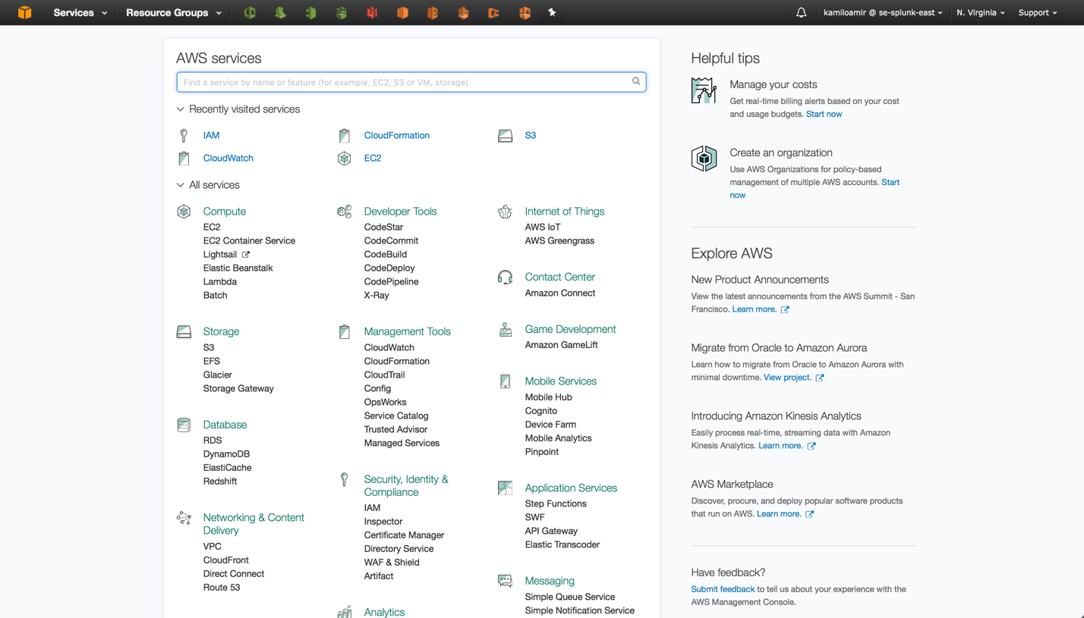

Click on Users on the left hand side and then click “Add User.”

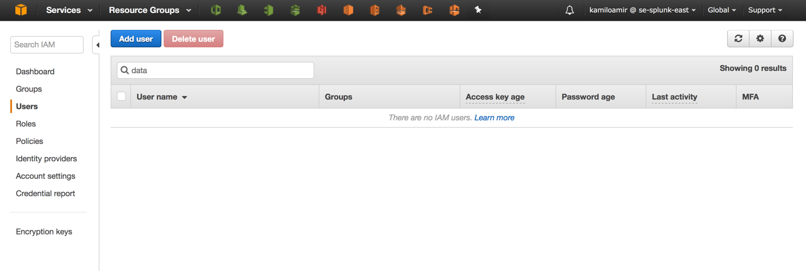

Give your account a name and make sure that you grant the user both “Programmatic access” and “AWS Management Console access”:

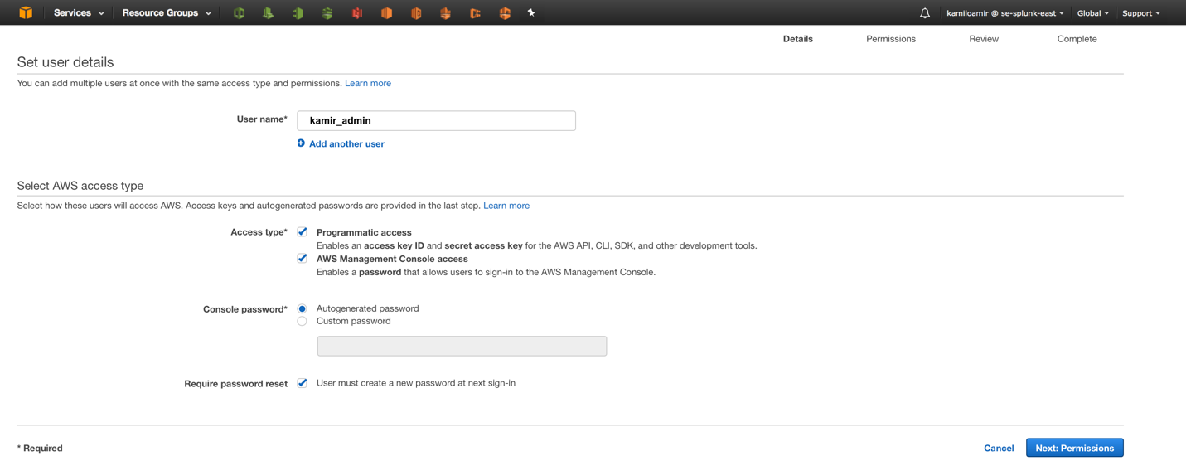

Under permissions you’re going to create a new Group:

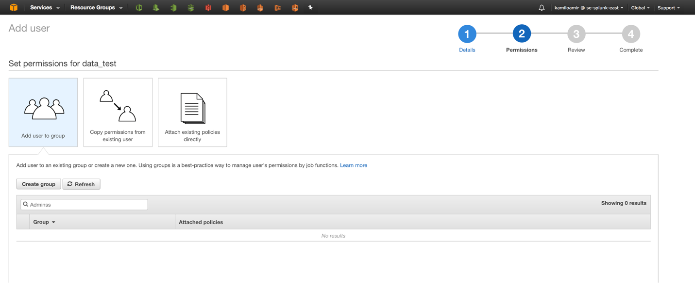

Grant the newly created group “AdministratorAccess”

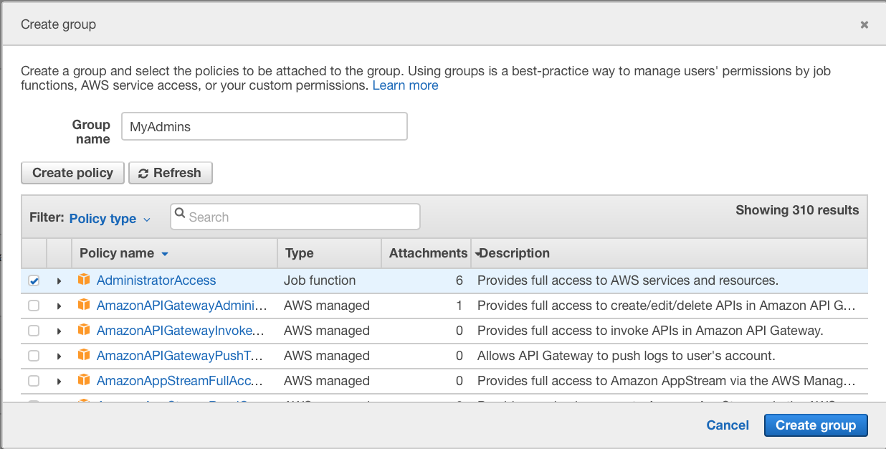

Once you have granted the newly created group AdministratorAccess, then scroll down and click on Review. Once you have checked that all the steps were followed, go ahead and click “Create User.”

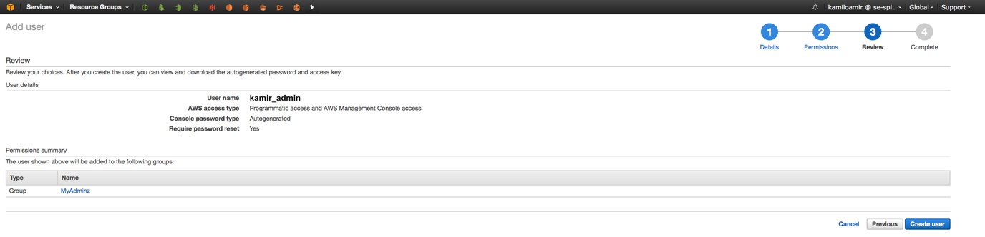

The next step is important, make sure that when you create the user that you click on Download .csv which has all of your credentials you will need to log in and access the API calls.

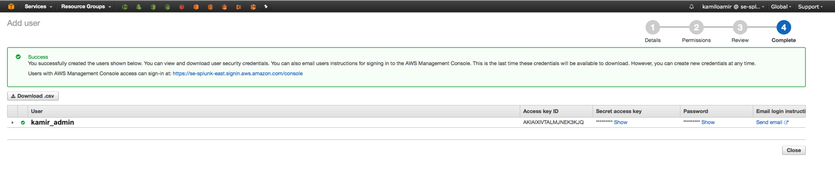

Enable the MFA on your user by click on your user account and selecting the third tab “Security credentials”:  
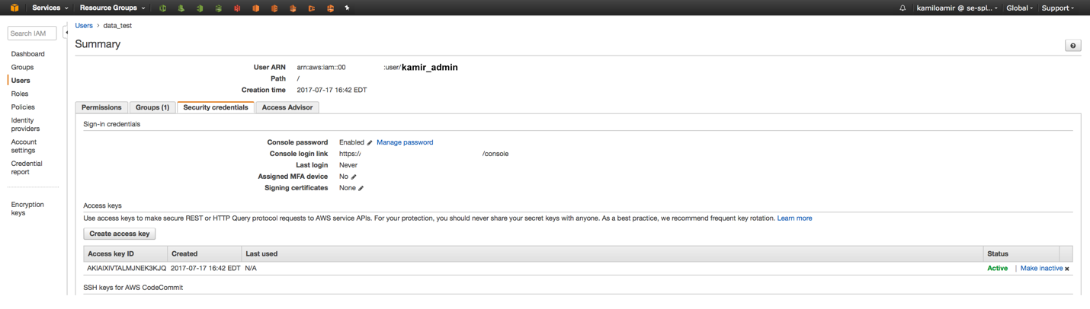

After clicking on the Assigned MFA device pencil, you will be prompted to create an MFA by using a device. I recommend using a virtual MFA (use Google Authenticator on your phone):

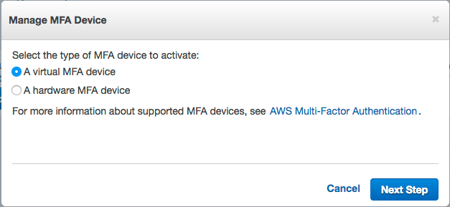

Scan the QR code and see the six-digit codes show up. Make sure to type in TWO different codes for each code. Type in the first code, then wait for it to expire then type in the second code. That is how the system will validate that it is synchronized with your device.

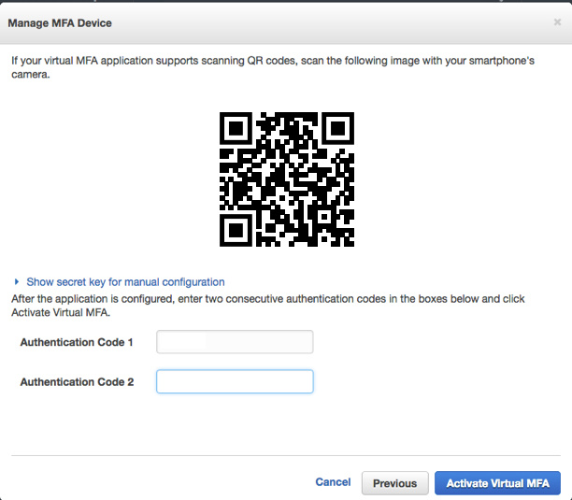

### Create Splunk Access IAM Policy

Just like creating the admin account, you will follow the same steps except you will only grant this Splunk Access user Programmatic Access and pair it with a restricted IAM policy. Let’s start by creating the Splunk Access IAM Policy. First, go to <http://docs.splunk.com/Documentation/AddOns/released/AWS/ConfigureAWSpermissions> and

select “Configure one policy containing permissions for all inputs.” Next, click on IAM then select Policies from the side menu:

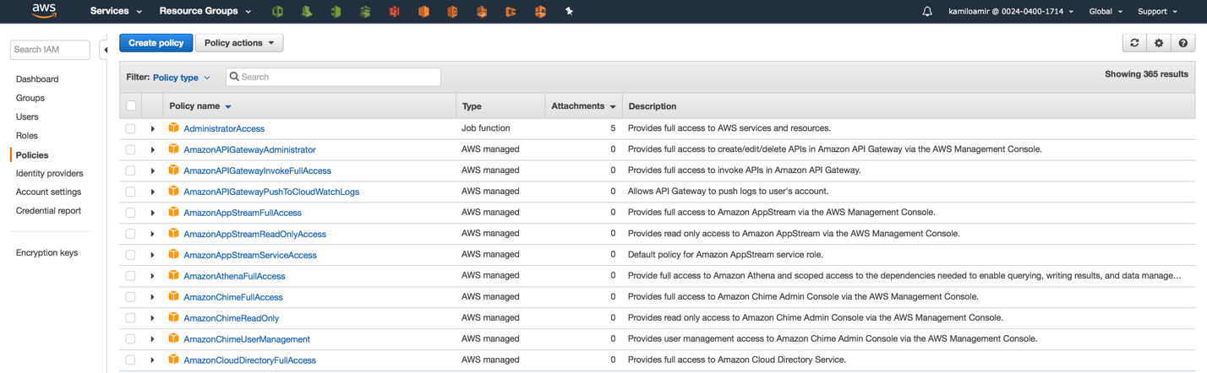

Click on Create Policy, then select “Create Your Own Policy”:

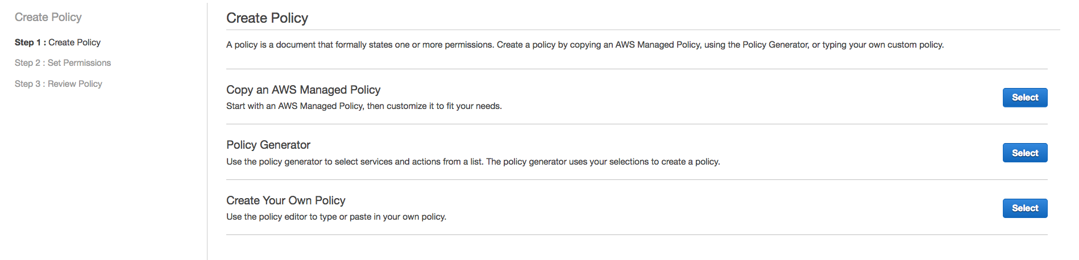

Give the Policy a name, I suggest using ‘SplunkAccess’ and a simple description, then paste the JSON policy from the docs page and click Create Policy:

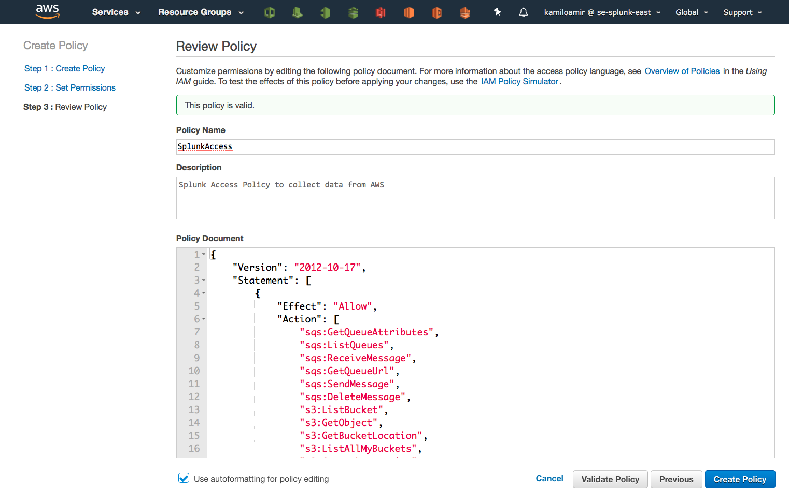

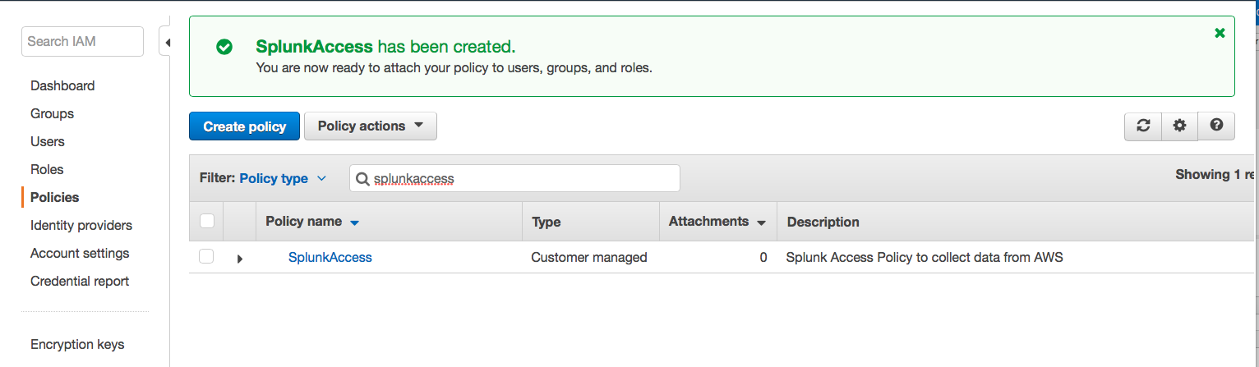

### Create EC2 Role

The EC2 role is going to be used to attach an IAM role to an EC2 instance. This is used when the customer is not allowed to use an Access Key / Secret Key to access their services in AWS. Under the IAM Service, click on Roles along the left hand side, then click “Create Role”:

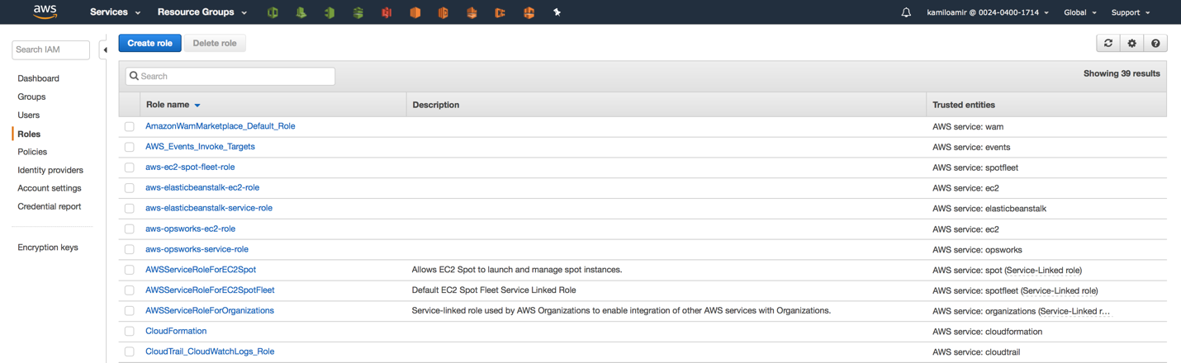

Select AWS Service then click on EC2:

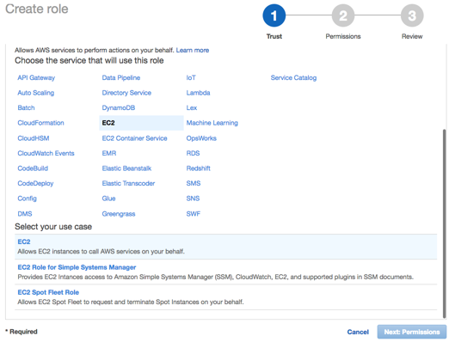

Then click here.

Click here first.

Click on Next: Permission

Search for the newly created “SplunkAccess” policy and click the checkbox next it:

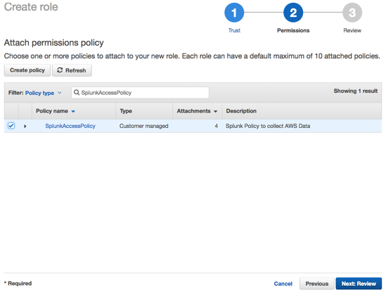

Click “Next: Review”

Give the role a name, I’d suggest “SplunkEC2Role” and a brief description:

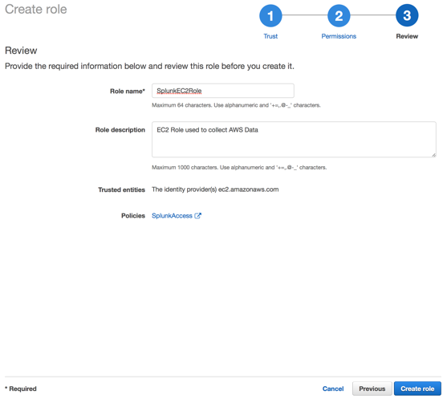

Click Create role

#### When to use: IAM User, AssumeRole and EC2 Role

There are different ways to access your AWS Services, each one is used for a specific use case. See Appendix to see how to configure IAM User and multiple account roles.

IAM User:

This scenario is used when a customer does not have too many restrictions in place for access their AWS environment. They are allowed to use an Access Key / Secret Key and have direct access to policies with their IAM user accounts. Typically this is done during a proof event or when customers are ‘testing out’ the Splunk App for AWS.

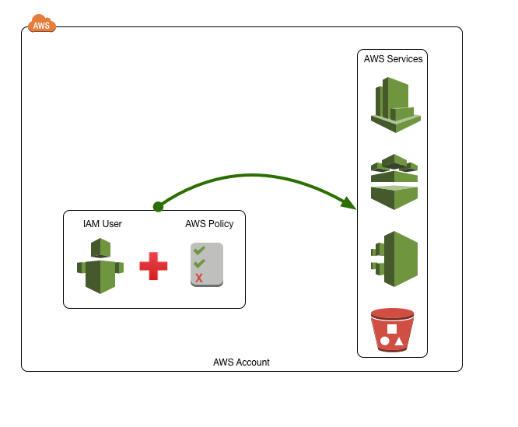

AssumeRole with IAM User:

Once the customer starts to have policies in place to access AWS, their security organization might impose restrictions as to which users or roles have access to the data on AWS. In this scenario, the IAM user does not have explicit access to the AWS Services but has the ability to assume the role of that does have access to the services.

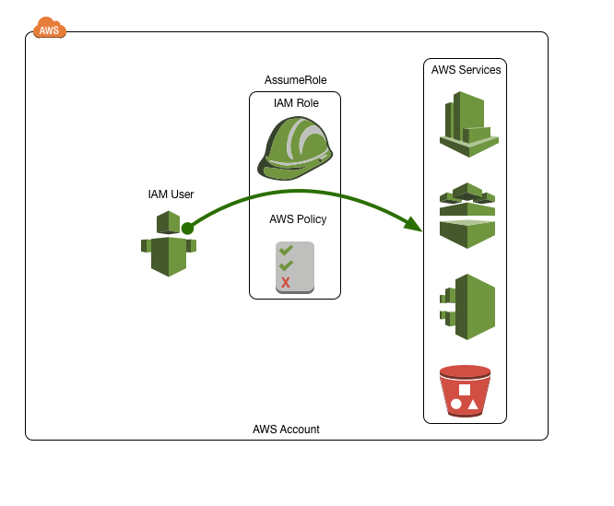

##### AssumeRole with EC2 Instance:

This scenario is relevant when a security team does not allow for users to access AWS with IAM users and require a service account to access the AWS services. This is when an EC2 Role with the IAM policy is used to access the services. This is generally the best way to access the data when you are not allowed to use Access / Secret keys for authentication.

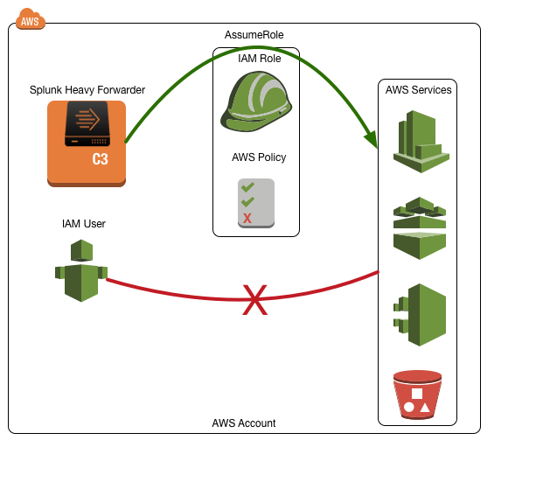

### Setup AWS Config

This section will cover setting up AWS Config which provides an inventory of your AWS resources and a history of configuration changes to these resources. The steps we are going to take will cover setting up the Config Service in your specific region, if you have multiple AWS regions, you will need to set up this service in each one. This service will create a notification in the SNS Topics and save the event to an S3 bucket. Splunk will listen to the SNS Topic via an SQS (Simple Queue Service); once a new event has been written to the SQS, Splunk will retrieve and index the notification from SQS and the event from the S3 bucket.

Overview of Splunk Data Collection for AWS Config:

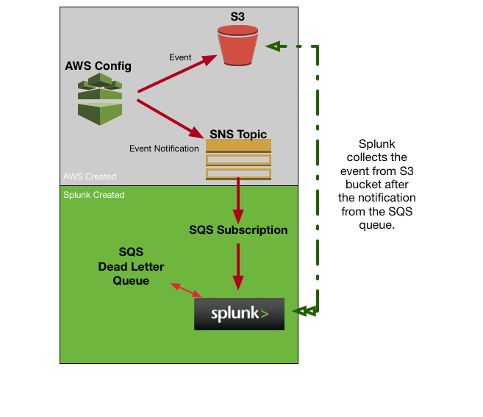

Start by click on Config under Management Tools:

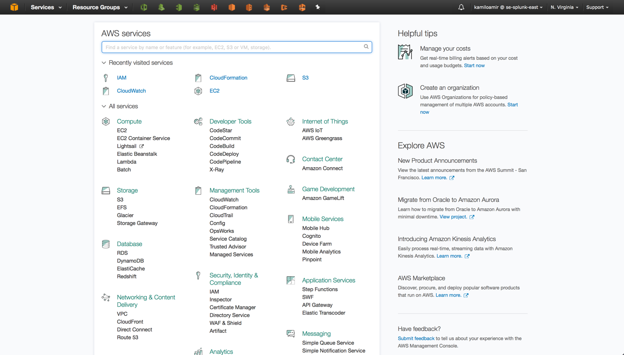

Click on Get started:

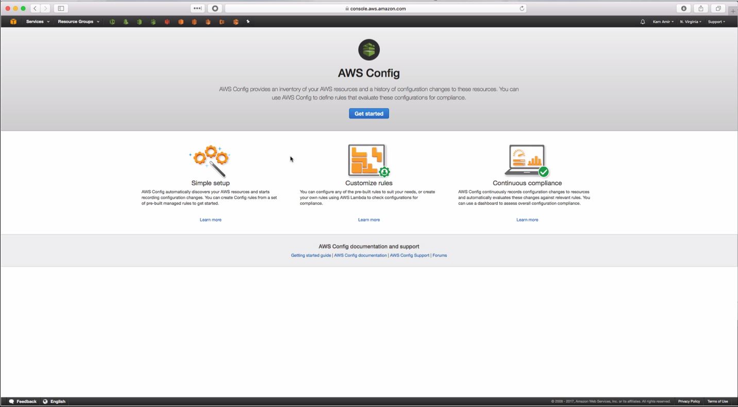

Under “Resource types to record”, make sure to have both boxes checked for “All Resources” :

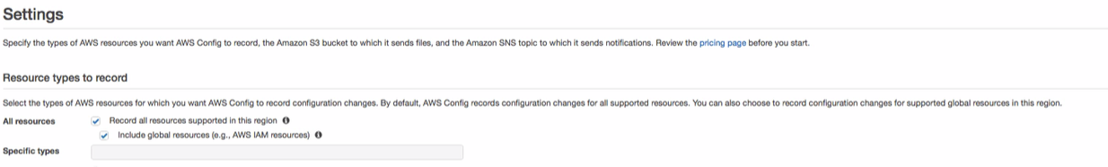

Amazon S3 bucket*, use the default settings, Create a bucket and the Bucket Name should be config-bucket-<your_aws_account_id>

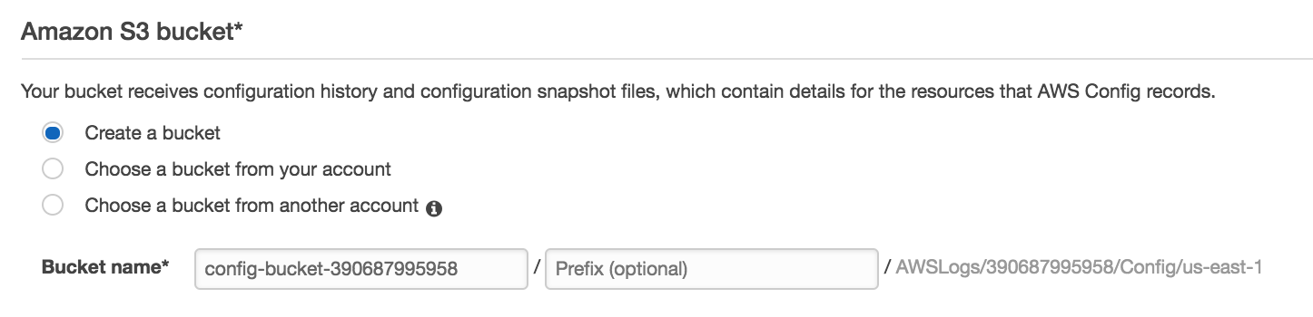

**Pro Tip** All AWS S3 buckets must be unique to the world, therefore you cannot just pick “config-bucket” for your S3 bucket because it has most likely already been selected by someone else in the S3 ecosystem. This is why the name is config-bucket- your unique account id.

Amazon SNS topic, make sure you enable “Stream configuration changes and notifications to an Amazon SNS topic”

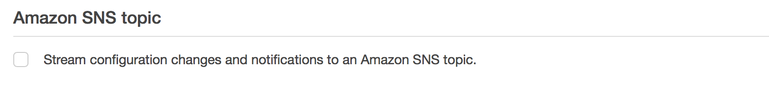

Changes to this when you enable it:

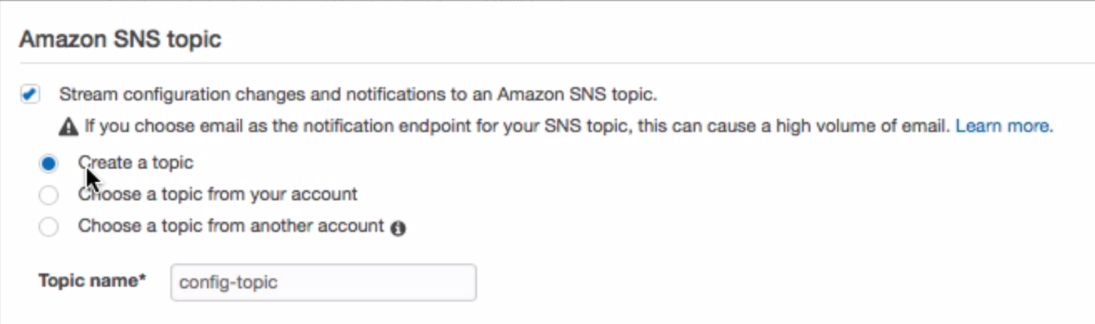

Use the defaults and leave the Topic name to config-topic.

AWS Config role*, leave the default enabled:

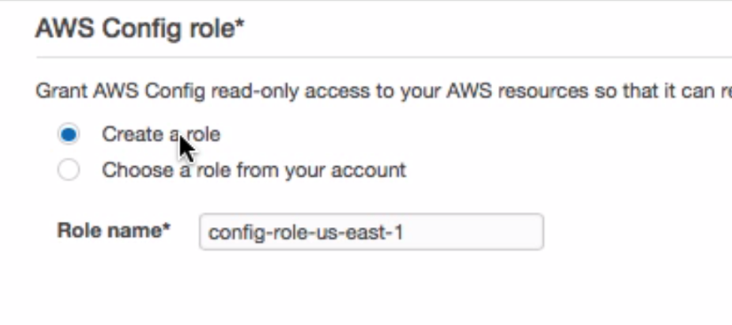

For now, you can skip the creation of any AWS Config Rules. We can come back to this later to create some rules so you can see how they show up in the Splunk App for AWS.

Review AWS Config:

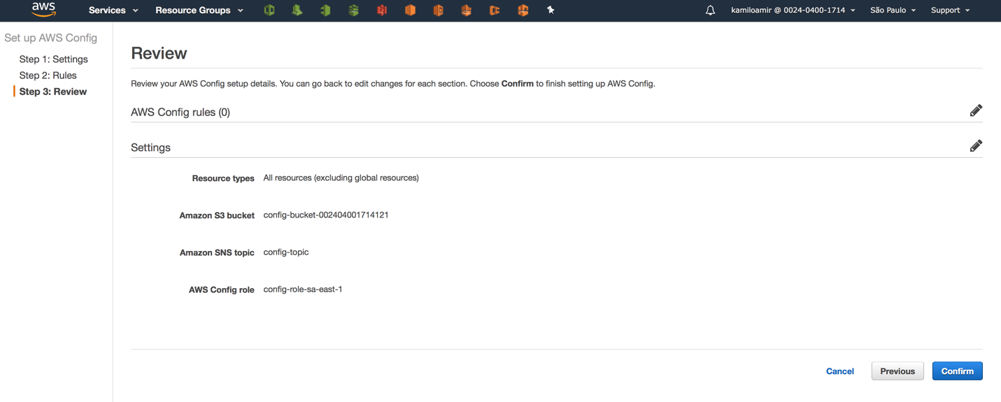

Review the changes and click on Confirm. Give it a few minutes and your AWS Config service should be setup for your account.

#### Setting up Simple Queue Service (SQS) for Config

Start by going to the Simple Queue Service (SQS) found under Messaging:



Once in the SQS, click on Create New Queue:

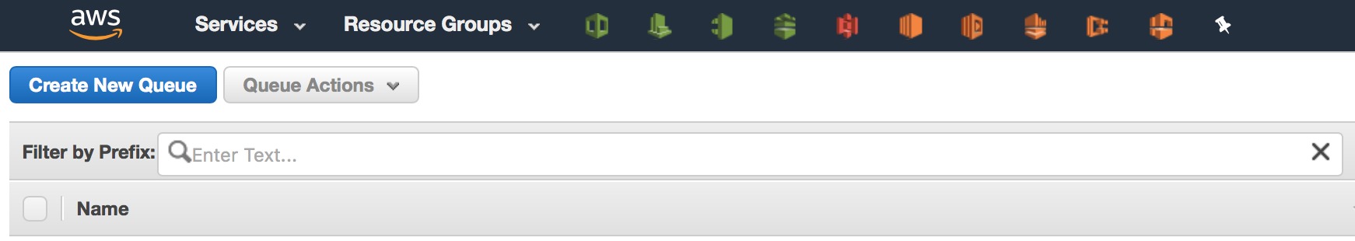

Give your queue a name, I would suggest “config-subscription” and use ‘Standard Queue’:

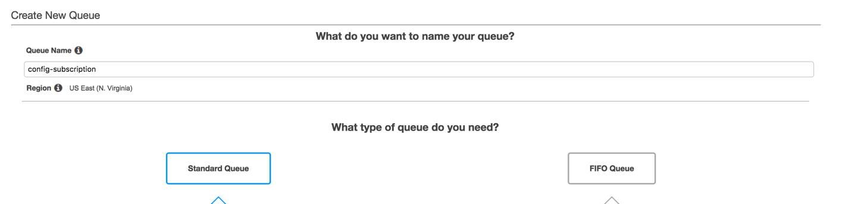

Click Quick-Create Queue:

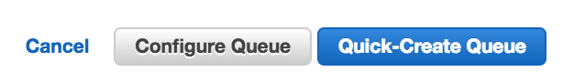

Now, subscribe the newly created queue to the AWS Config SNS topic created earlier. Click on Queue Actions and select “Subscribe Queue to SNS Topic”:

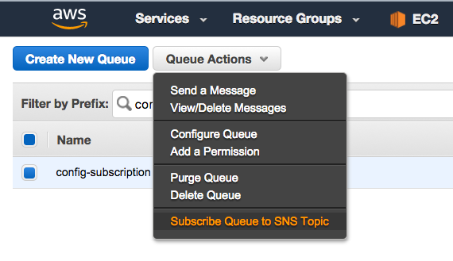

In the Pop-up, select the “config-topic”:

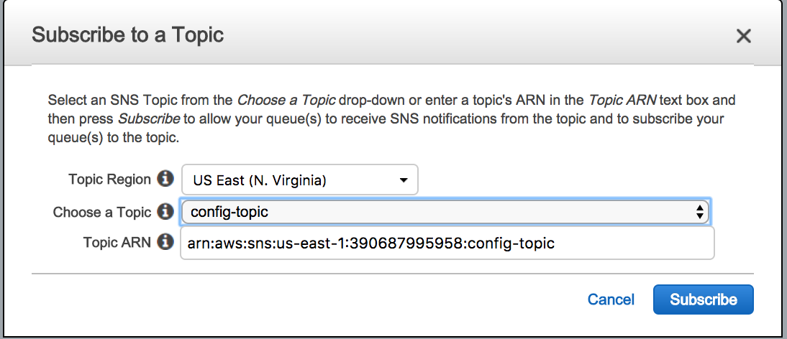

In order to use the new input modular input (SQS Based S3) you will need to create a dead letter queue. Let’s start by creating another (standard) queue in SQS, call it “config-dlq”:

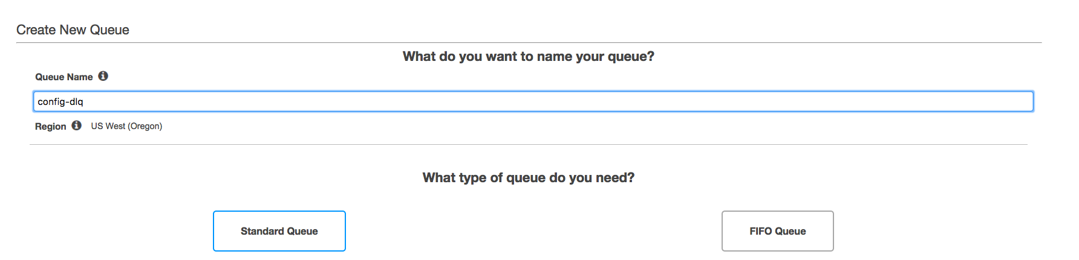

Click Quick-Create Queue:



Configure the “config-subscription” queue to now use the config-dlq (dead letter queue). Select the “config-subscription” queue and then click on Queue Actions and “Configure Queue”:

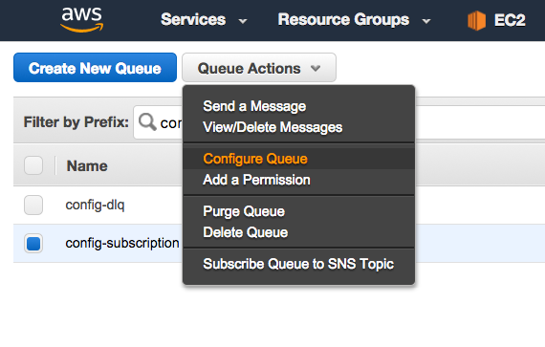

In the popup, go to the Dead Letter Queue Settings and enable the “Use Redrive Policy” and select the “config-dlq” queue; set the Maximum Receives to 500:

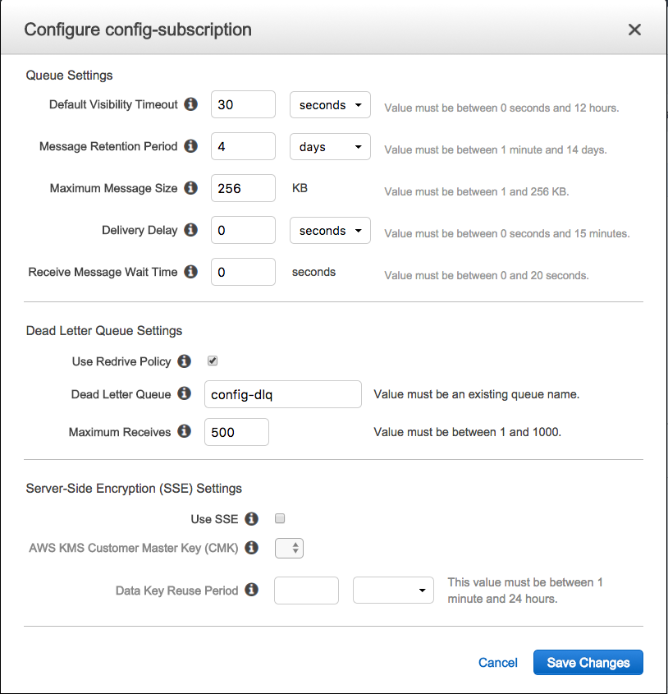

Click Save Changes.

### Set up AWS CloudTrail

This section will cover setting up AWS CloudTrail which **AWS CloudTrail** is an application program interface (API) call-recording and log-monitoring Web service offered by Amazon Web Services (**AWS**). This service will create a notification in the SNS Topics and save the event to an S3 bucket. Splunk will listen to the SNS Topic via an SQS (Simple Queue Service); once a new event has been written to the SQS, Splunk will retrieve and index the notification from SQS and the event from the S3 bucket.

Overview of Splunk Data Collection for AWS CloudTrail:

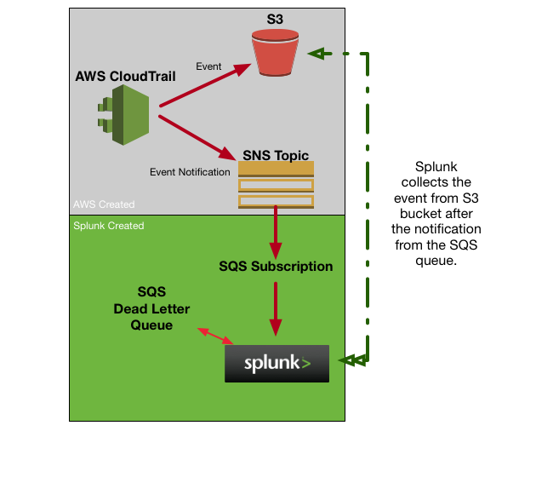

Start by click on CloudTrail under Management Tools:



Click on Get Started Now:

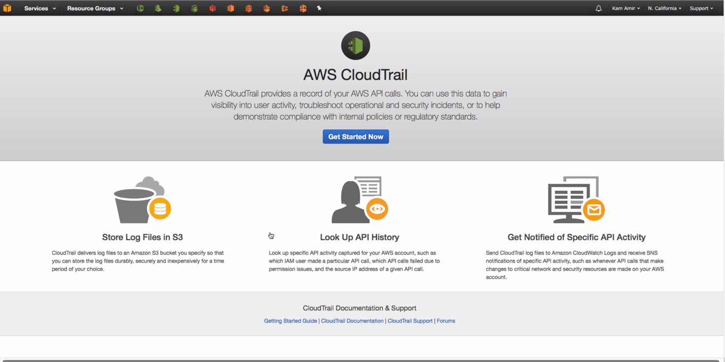

Under “Create Trail” (or Turn On Trail), give your trail a name (cloudtrail) and leave all the defaults enabled:

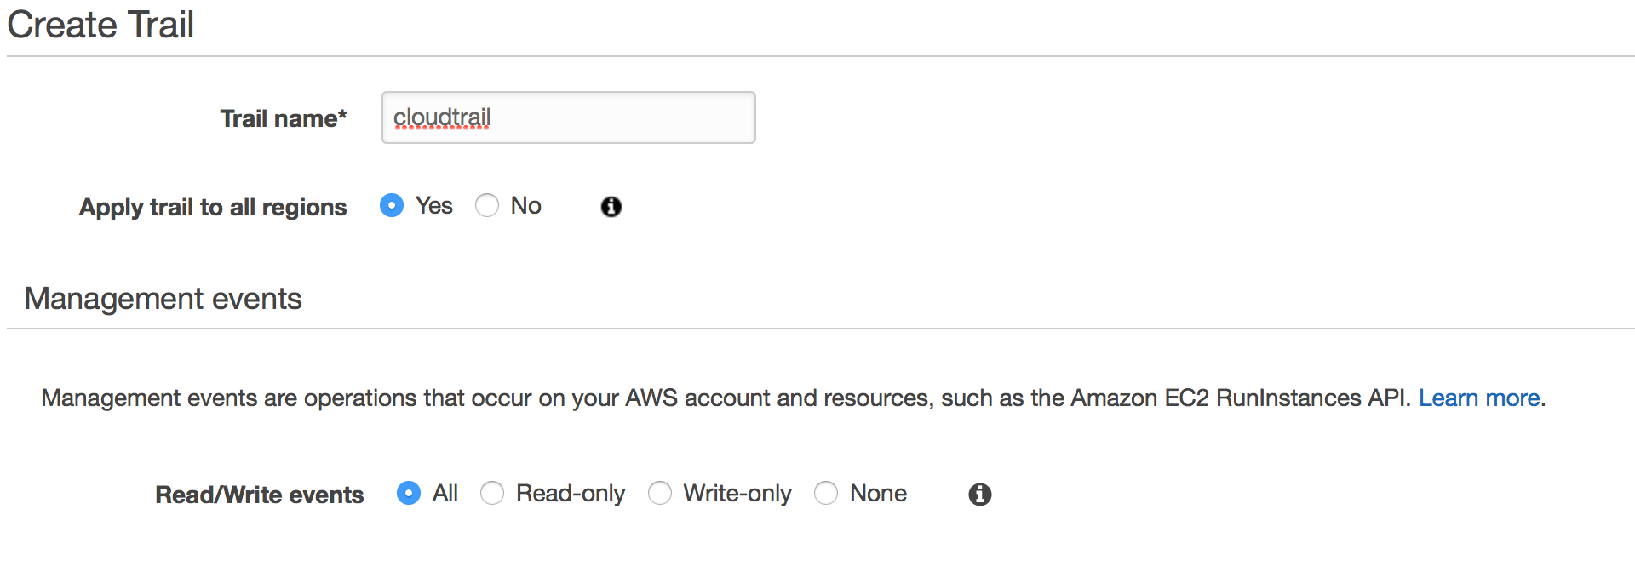

Storage location, Create a new bucket and the Bucket Name should be cloudtrail-<your_aws_account_id>

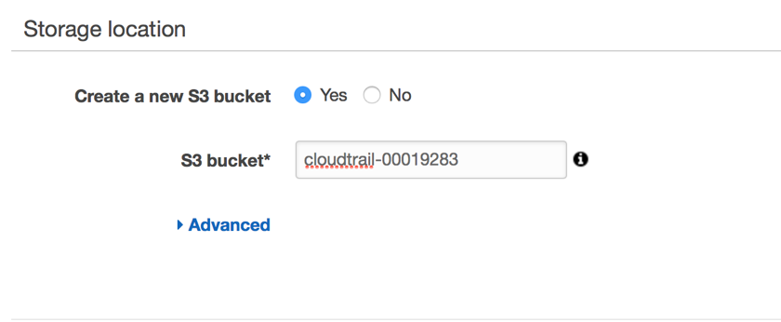

Click on “Advanced”

Under the Advanced settings, make sure to Click the Yes radio button for : “Send SNS notification for every log file delivery” and “Create a new SNS topic” and name your topic ‘cloudtrail’:

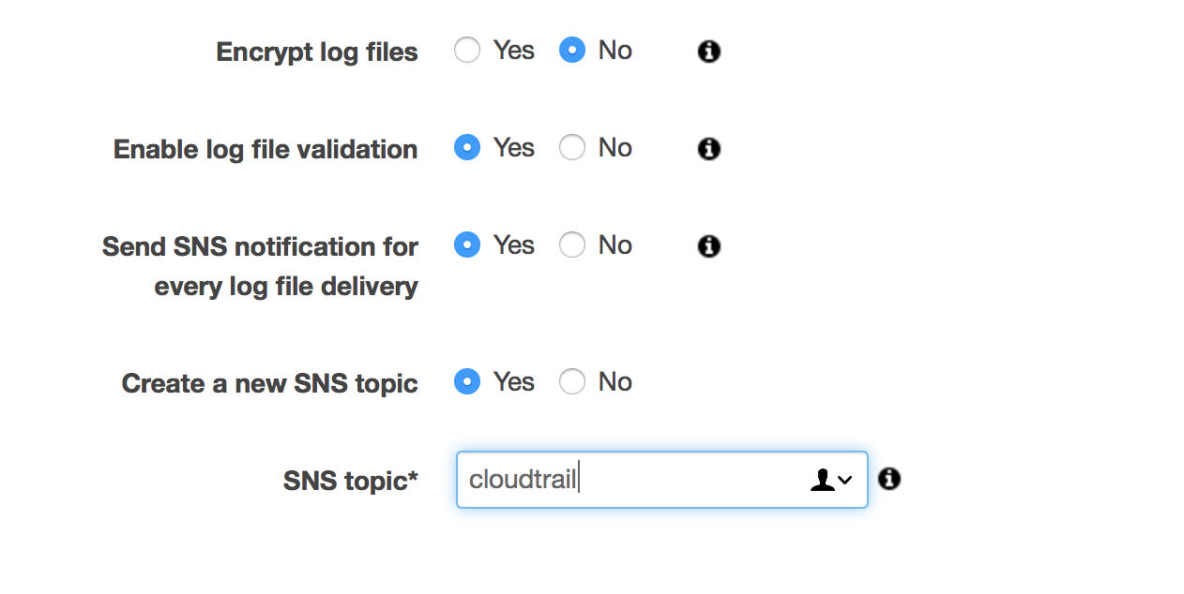

Click Create

#### Setting up Simple Queue Service (SQS) for CloudTrail

Start by going to the Simple Queue Service (SQS) found under Messaging:



Once in the SQS, click on Create New Queue:



Give your queue a name, I would suggest “cloudtrail” and use ‘Standard Queue’:

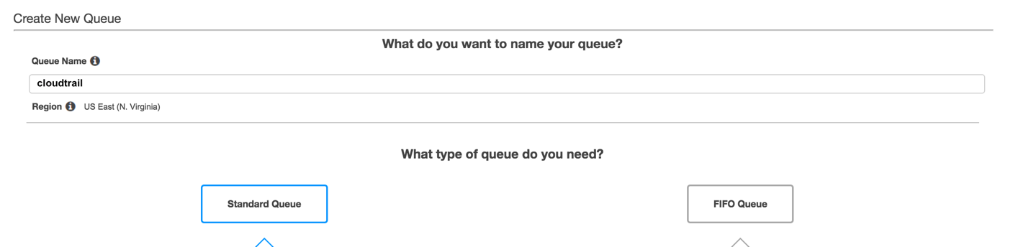

Click Quick-Create Queue:



Now, subscribe the newly created queue to the AWS CloudTrail SNS topic created earlier. Click on Queue Actions and select “Subscribe Queue to SNS Topic”:



In the Pop-up, select the “cloudtrail”:

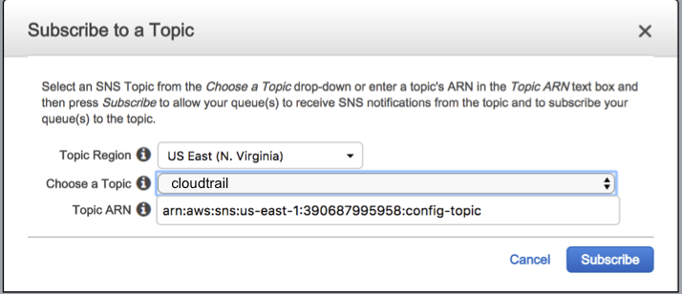

In order to use the new input modular input (SQS Based S3) you will need to create a dead letter queue. Let’s start by creating another (standard) queue in SQS, call it “cloudtrail-dlq”:

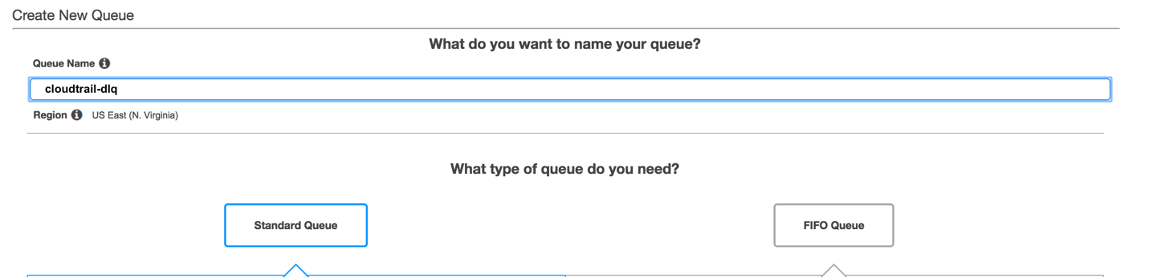

Click Quick-Create Queue:



Configure the “cloudtrail” queue to now use the cloudtrail-dlq (dead letter queue). Select the “cloudtrail” queue and then click on Queue Actions and “Configure Queue”:

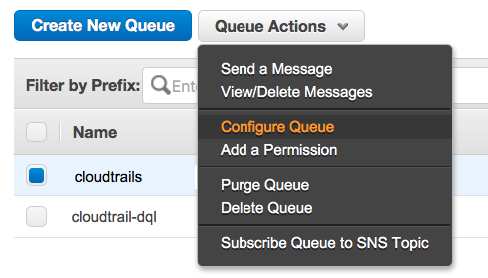

In the popup, go to the Dead Letter Queue Settings and enable the “Use Redrive Policy” and select the “cloudtrail-dlq” queue; set the Maximum Receives to 500:

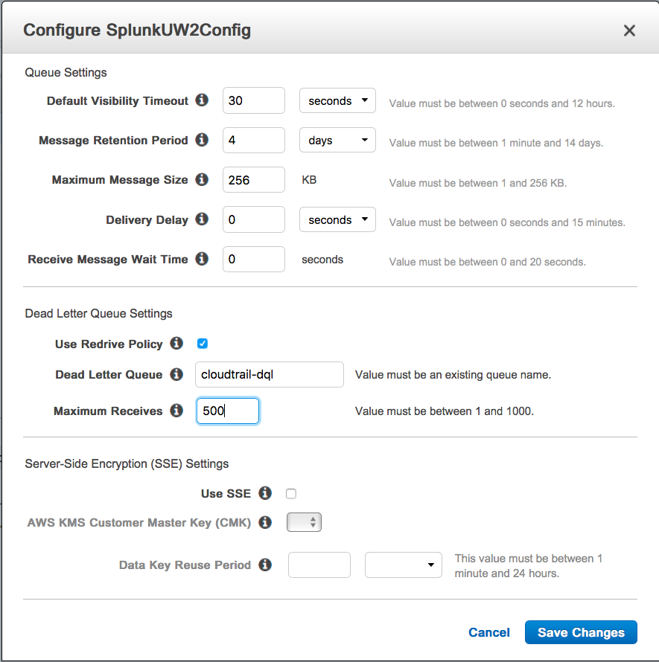

Click Save Changes.

#### Setup CloudWatch Logs

The CloudWatch Logs service will allow us to collect the VPC Flow Logs from your AWS Deployment. This service can be used to collect other logs generated in your deployment, but for now we are going to focus on the VPC Flow logs. Let’s start by opening the CloudWatch service under Management Tools:



Click on Logs along the left hand menu and click “Create log group”:

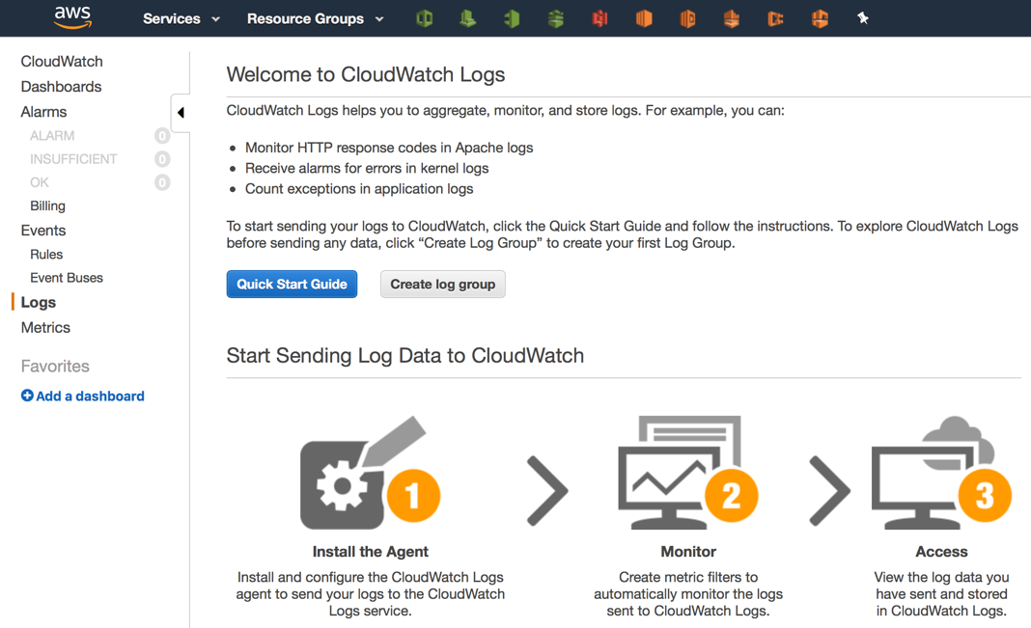

Name the CloudWatch Log Group “VPCFlowLogs” and click “Create log group”:

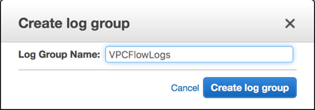

#### Setting up VPC Flow Logs

This section will create the VPC Flow Logs that are generated by your VPC (Virtual Private Cloud). Think of these as your firewall access logs. Let’s start by click on VPC under Networking & Content Delivery:



If this is your first time setting up your AWS Deployment, you will need to create your VPC. Click on “Start VPC Wizard” and Select the first option “VPC with a Single Public Subnet”:

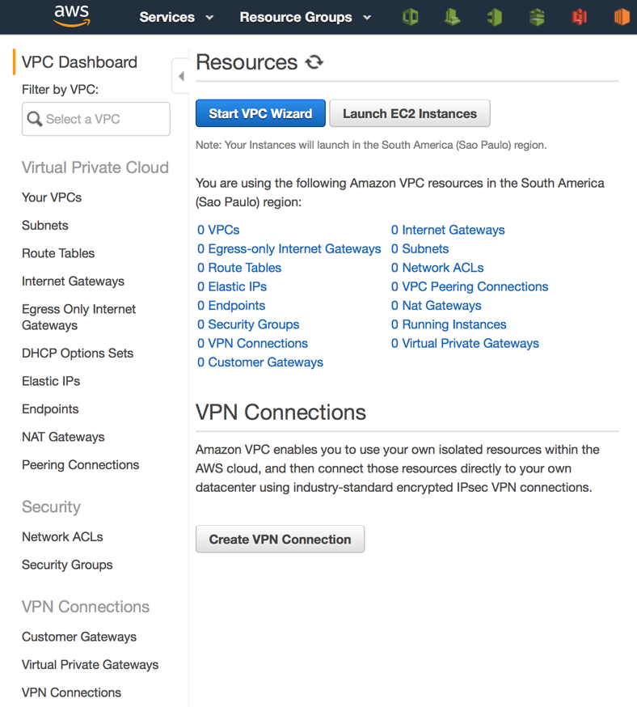

Click Select for VPC with a Single Public Subnet.

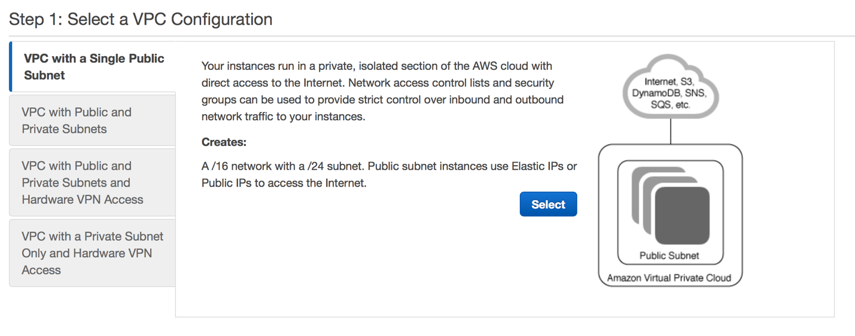

Name the VPC Primary and click Create VPC

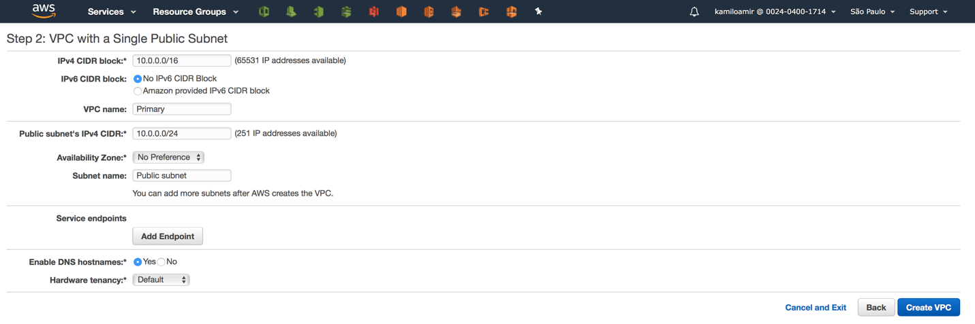

Click on Your VPCs along the left-hand side and select the Primary VPC:

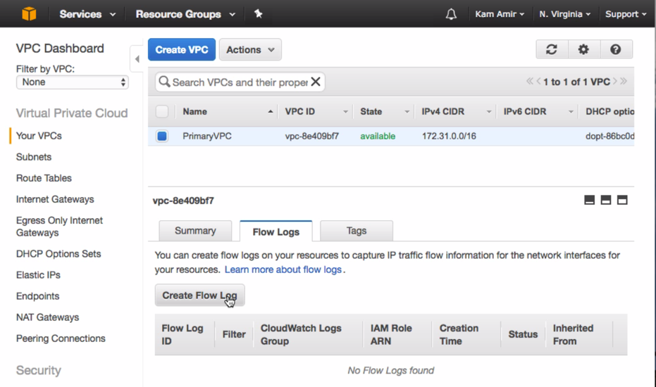After selecting your Primary VPC, click on the “Flow Logs” Tab located at the bottom of the screen. Click the “Create Flow Log” button.

Create Flow Log

Set the Filter* to All

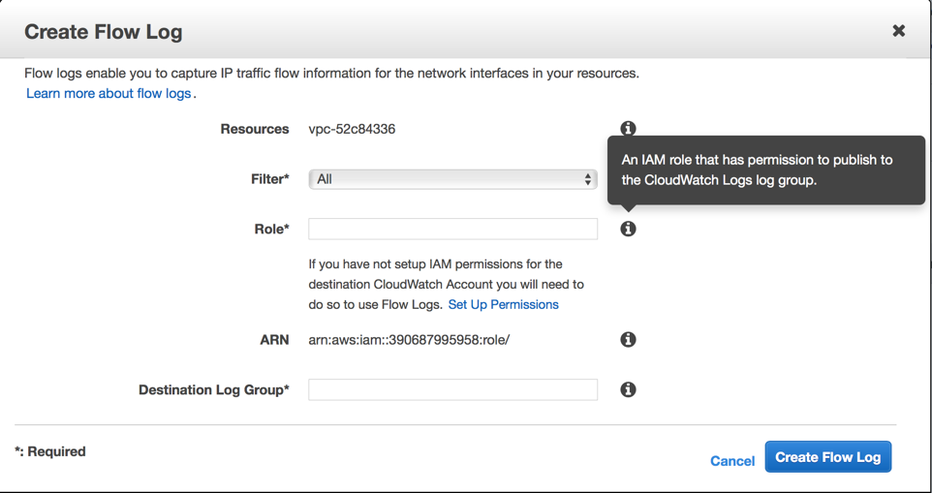This feature requires the creation of a new role that has access to the VPC Flow logs.

Click on Set Up Permissions.

This will open a new tab and you will see the newly created role called “flowlogsRole”, simply click on the Allow button at the bottom of the screen.

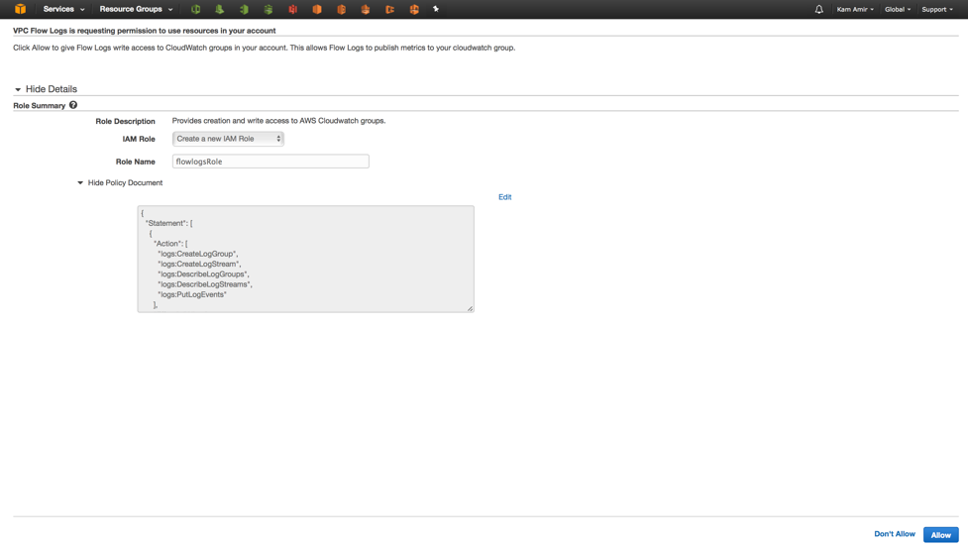

When you get back to the Create Flow Log screen, you will see that the role “flowlogRole” is now an option, select it:

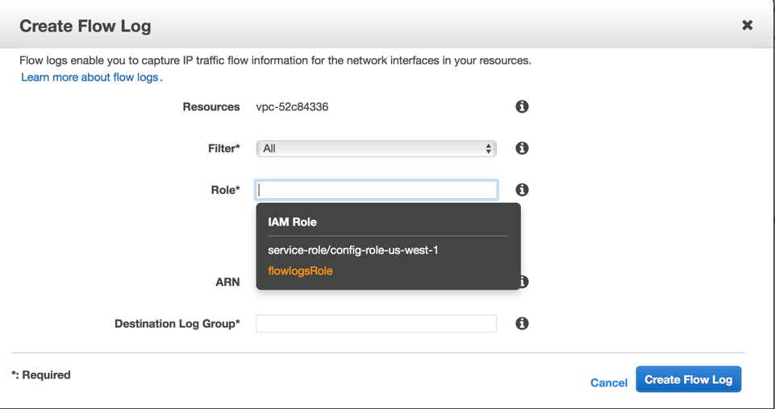

Finally, under Destination Log Group*, select the CloudWatch Log Group created earlier named “VPCFlowLogs”:

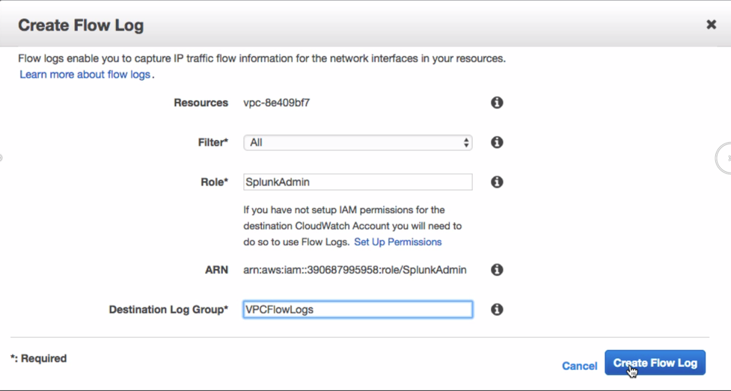

## Module 3 – Setting up Splunk Infrastructure

This module will cover setting up the appropriate Splunk infrastructure to collect the data produced by AWS. There are a few options to setup the infrastructure, for the abridged lab we will setup a Splunk Cloud Free Sales Trial, but for the normal class we will setup an Amazon AMI from the AWS Marketplace in your AWS Cloud.

### Splunk Cloud Sales Trial

Log onto Splunk.com and click on the Free Splunk button. From here, select the Splunk Cloud “Free Cloud Trial”:

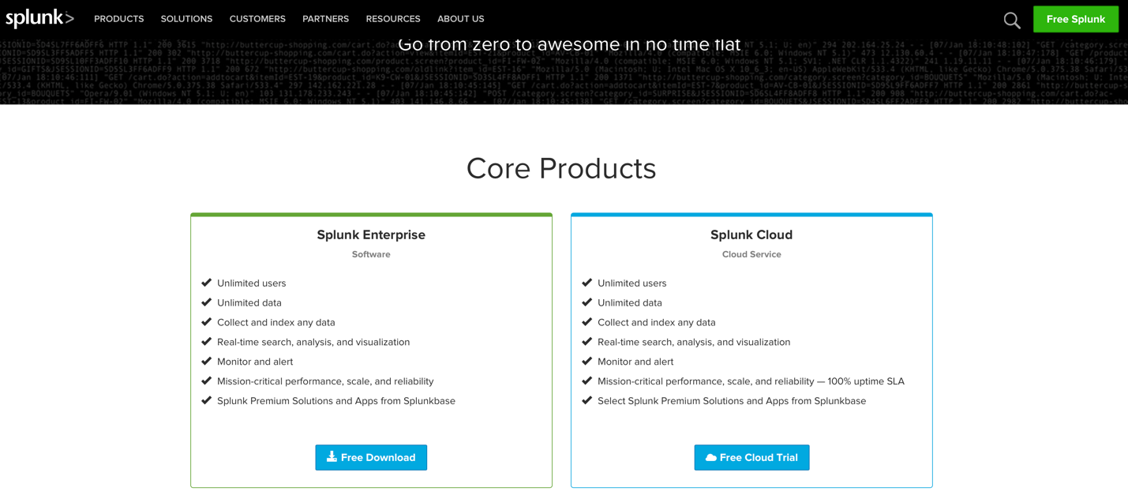

Once the Sales Trial has spun up, you will log into the deployment and install the Splunk App and Add-on for AWS.

### Amazon Image (AMI) Marketplace

Navigate to <https://aws.amazon.com/marketplace> search for “splunk”:

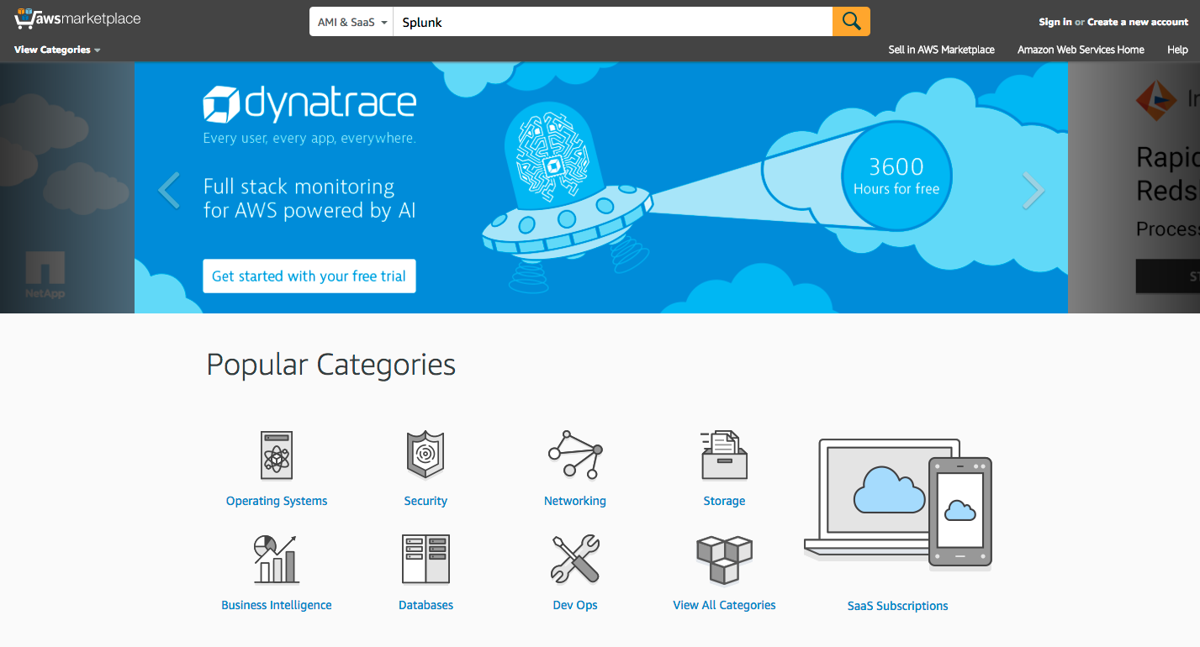

Select the “Splunk Enterprise” option and click on the “Continue” button:

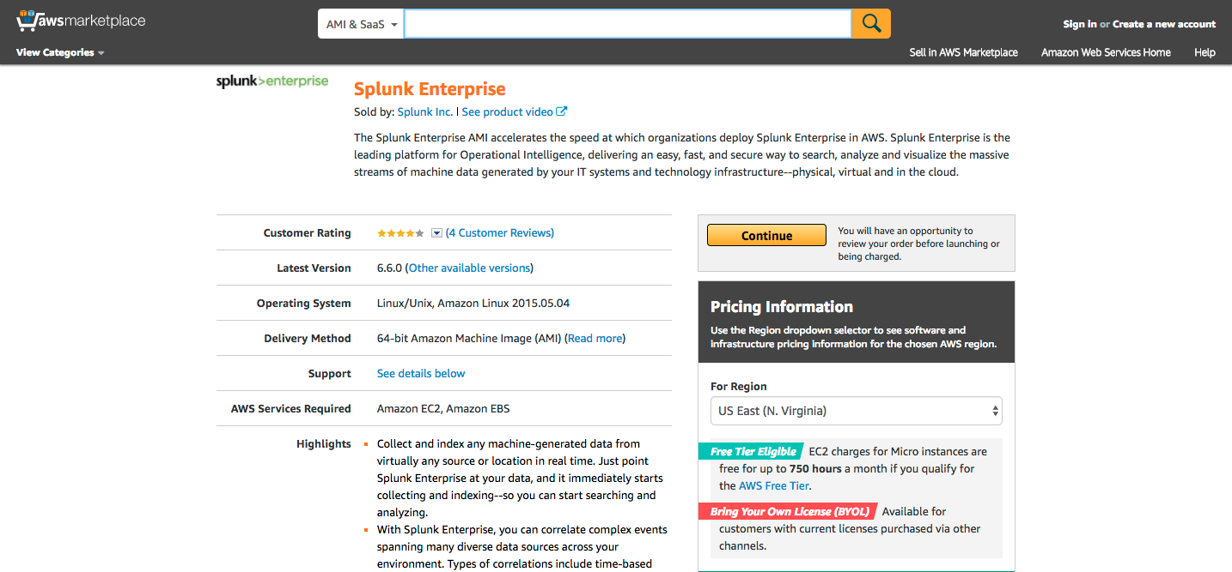

Now set to launch the instance using the Manual Launch option and click the “Accept Software Terms”:

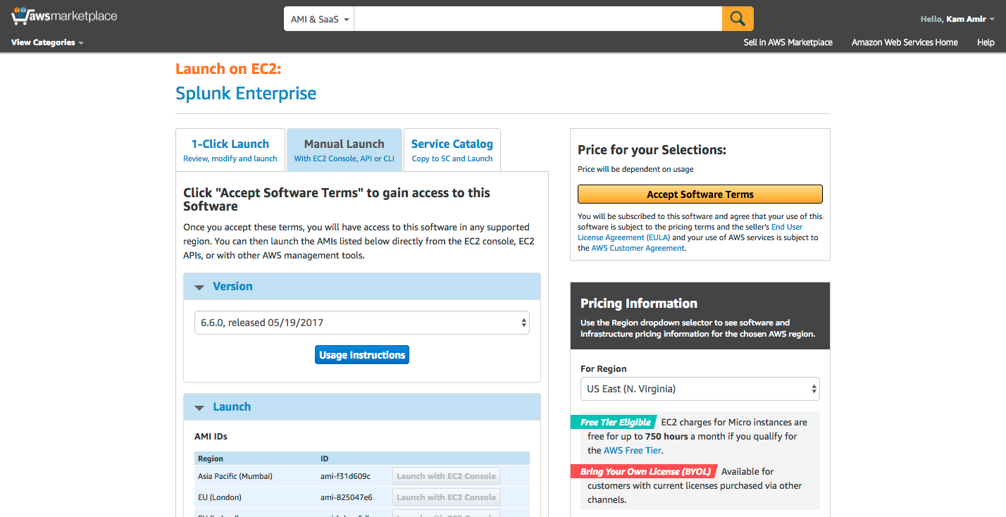

Click “Launch with EC2 Console” from the region you are using:

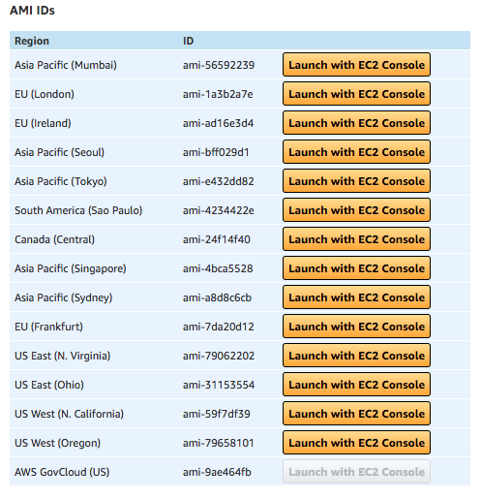

Now select the instance type, for this lab select “T2.large” then click “Next: Configure Instance Details”

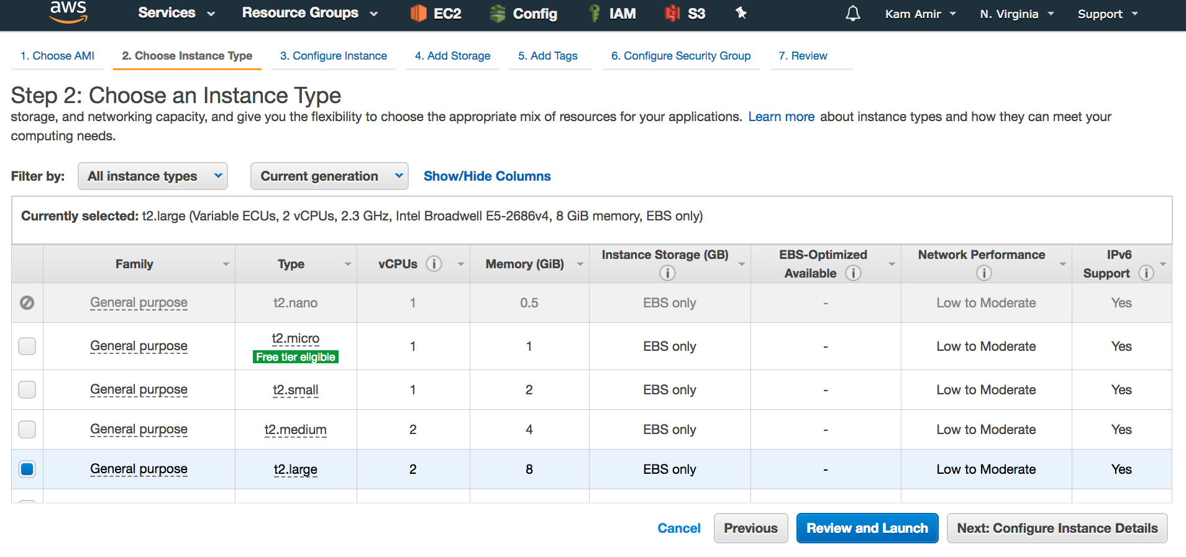

Leave all the defaults and click “Next: Add Storage”

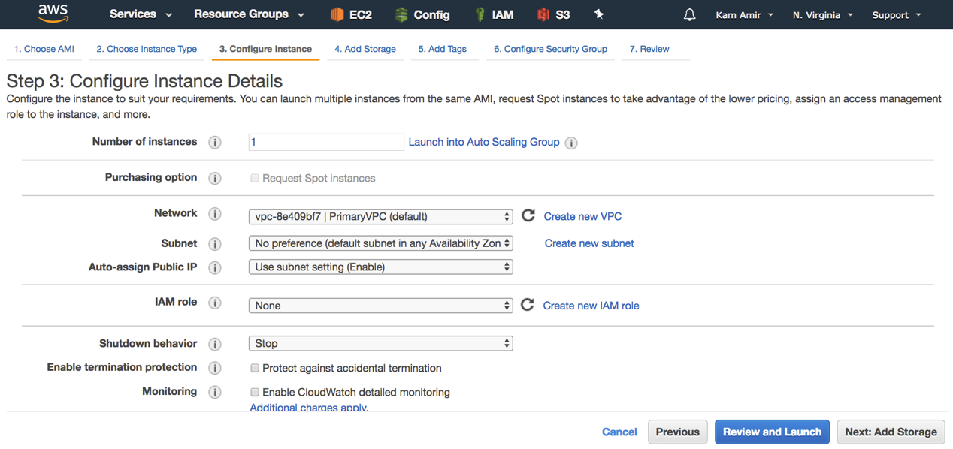

Add storage, make sure to change the default value from 8GB to 20GB and leave it as GP2, then click Next: Add Tags

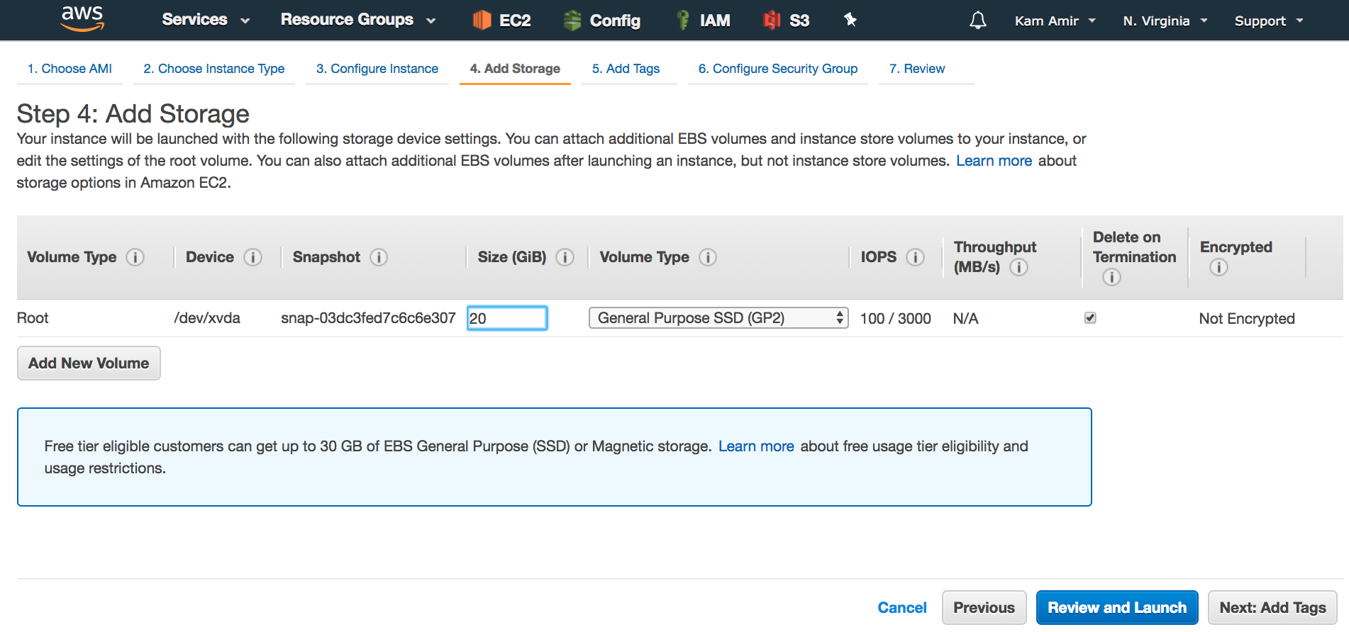

Under Tags, create three Key Tags, Application, Version and Purpose; fill them accordingly then click “Next: Configure Security Group”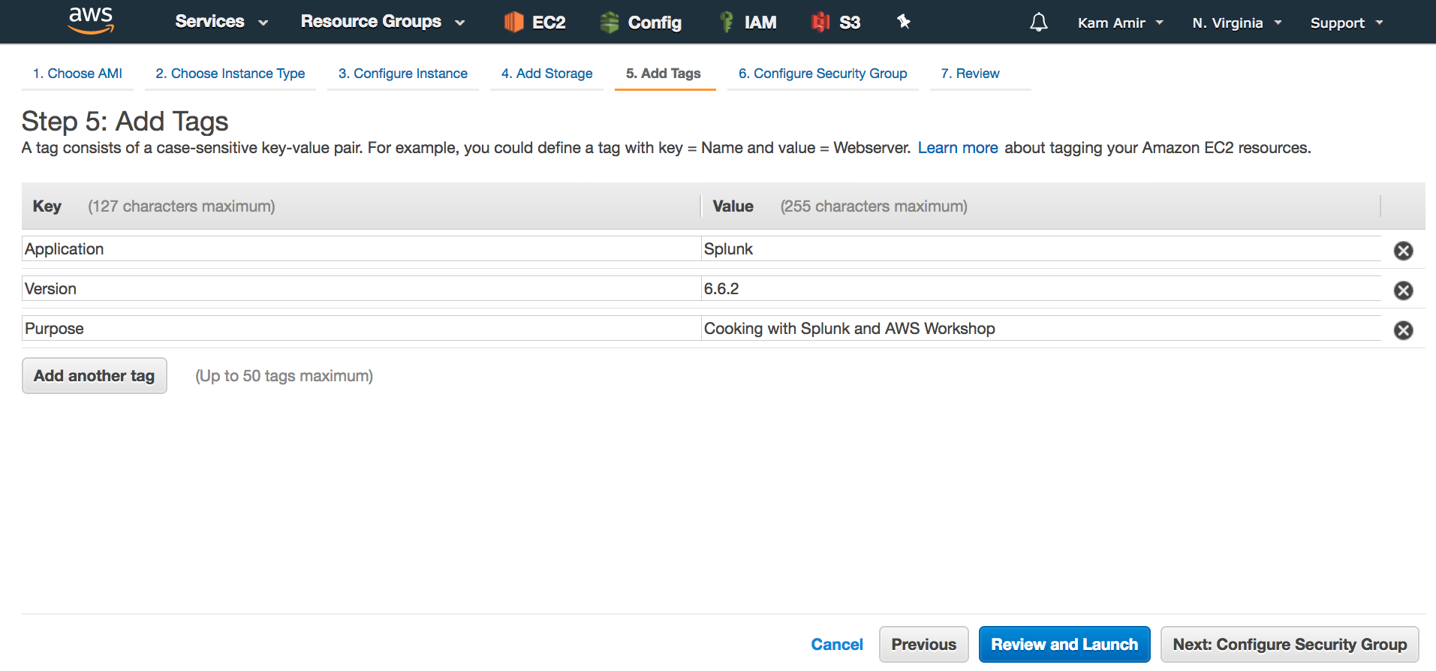

Under security Groups, add one rule TCP 8088 from 0.0.0.0/0 (Anywhere):

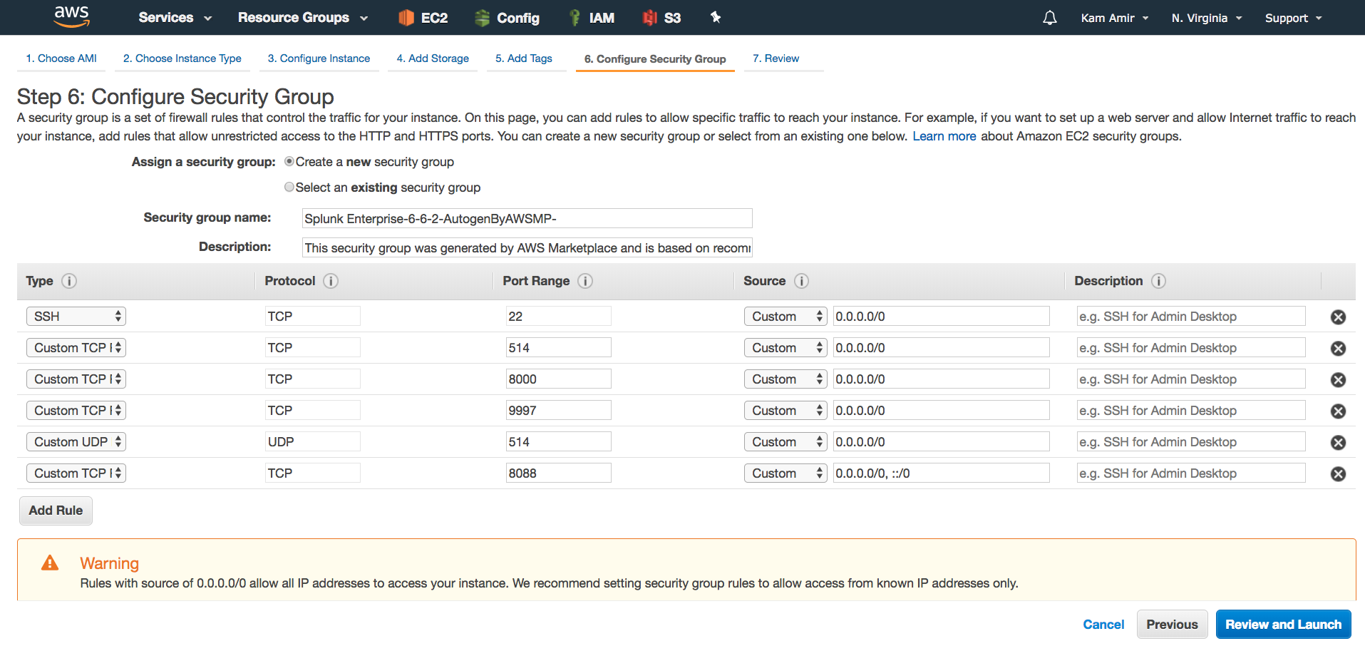

Click Review and Launch, then Launch the instance:

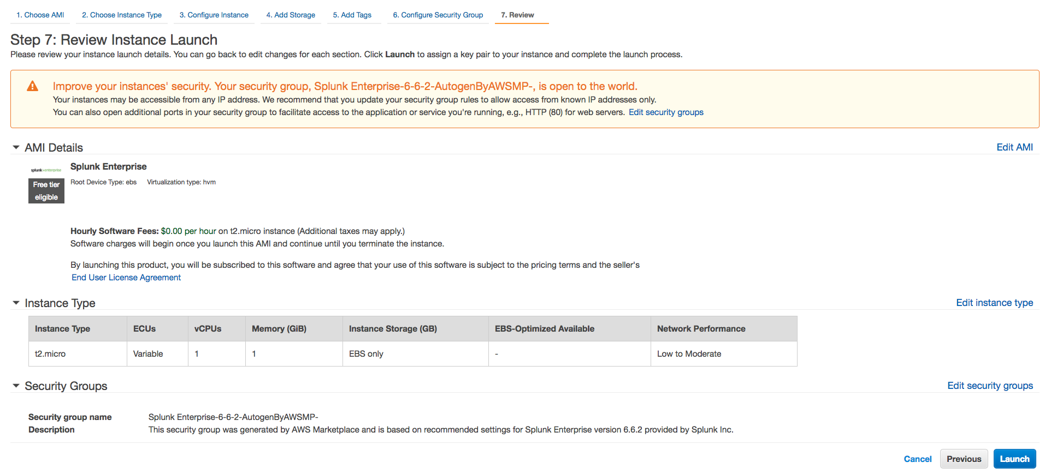

Create a key pair in case you need to SSH into the instance, for this lab you will not need to log into the instance via ssh. Download the key pair and click “Launch Instance.”

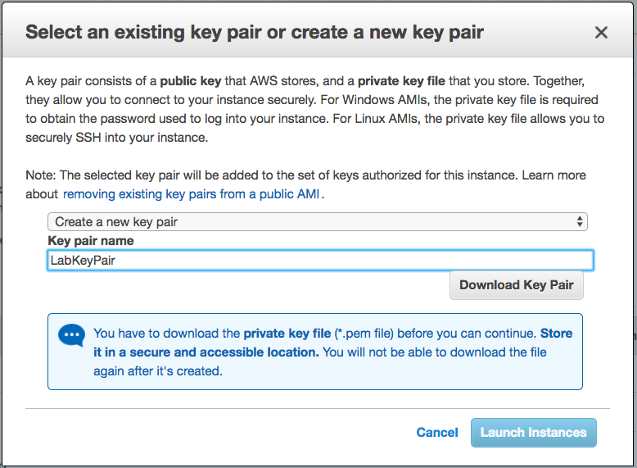

### Install Splunk App and Add-on for AWS

Log into the newly created instance, you can log in using the public IP and port 8000. Your log in will be username admin and the machine instance ID will be the password. This can be found in the EC2 Dashboard under Instance ID.

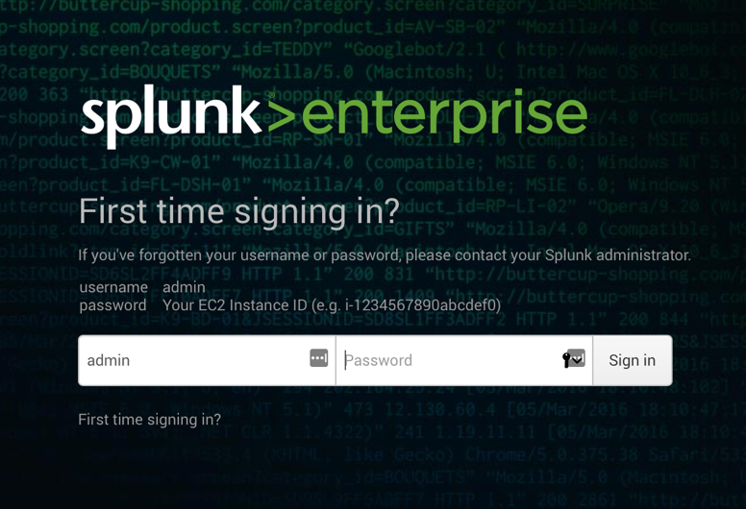

Once you’ve logged into your instance, click on the plus sign from the home screen and search for the “Amazon Web Services” apps.

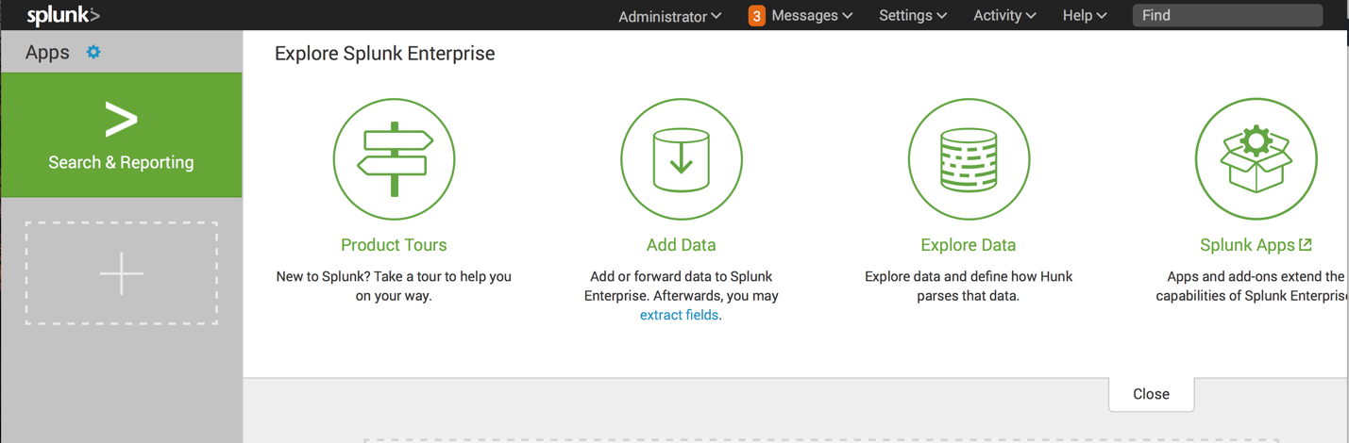

Install the Splunk Add-on for AWS:

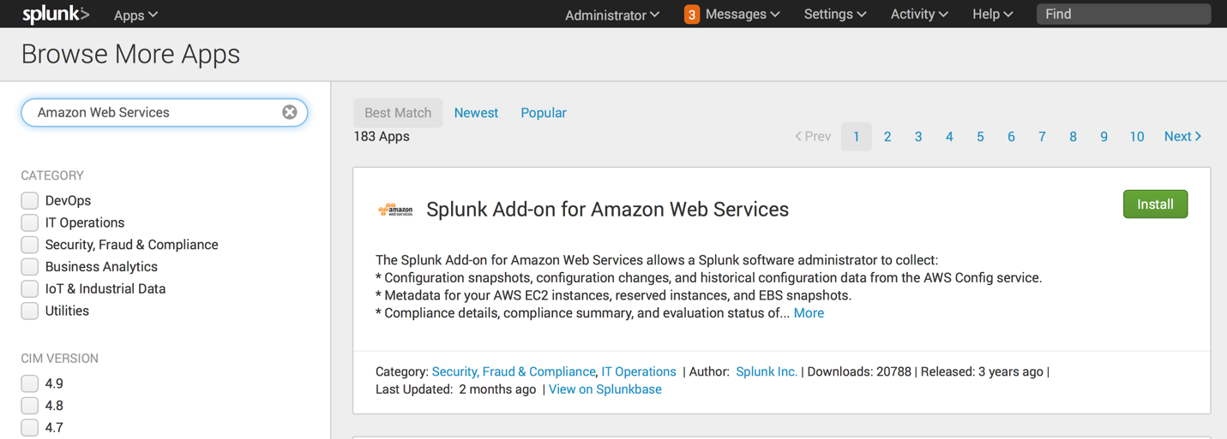

Do not restart, select the “Restart Later” option:

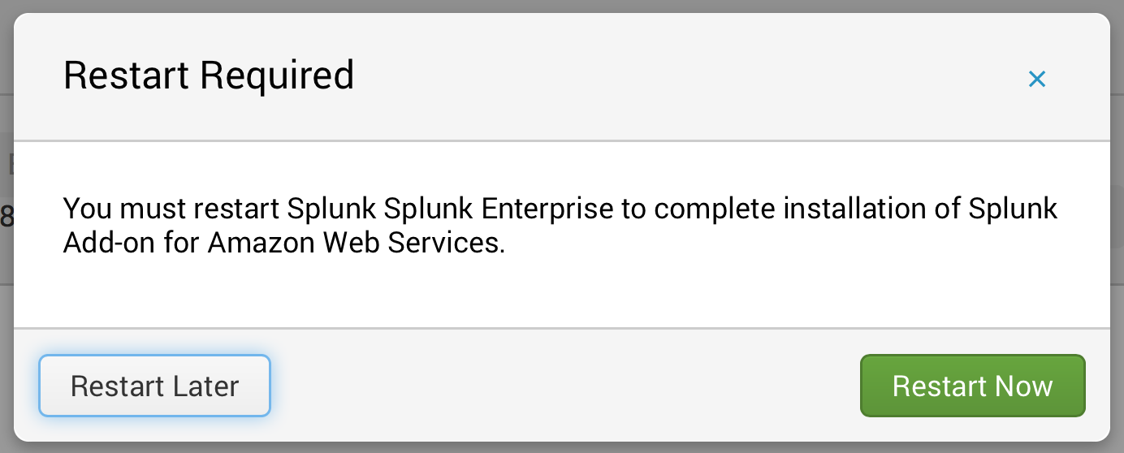

Install the Splunk App for AWS (Scroll down until you find it):

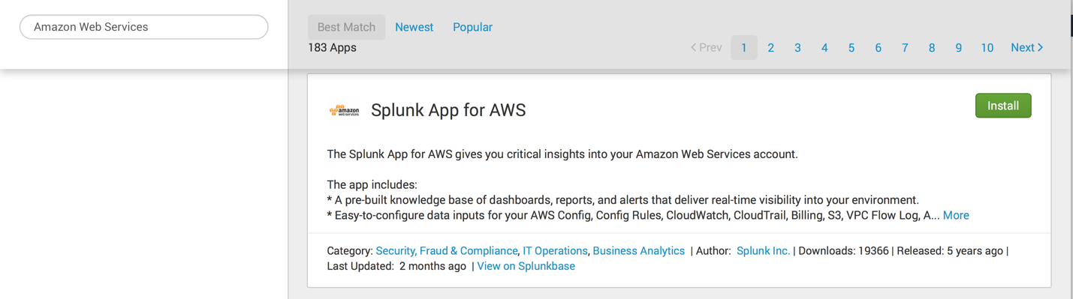

Once the App has done installing, go ahead and click “Restart Now”

### Setup Splunk HTTP Event Collector (HEC)

From your home screen, navigate to Settings -> Data Input -> HTTP Event Collector:

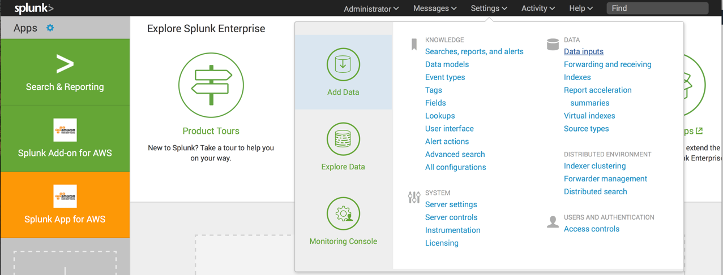

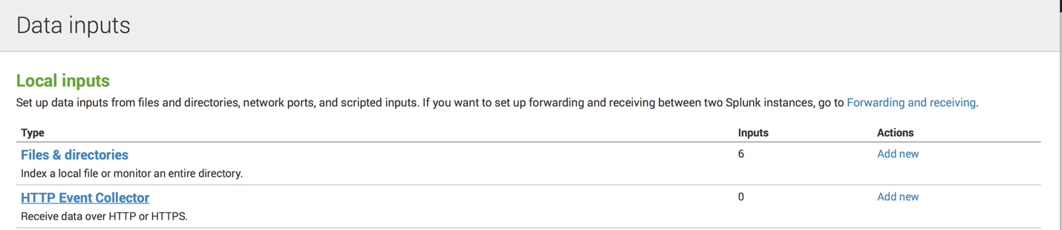

First, enable the HEC under Global Settings:

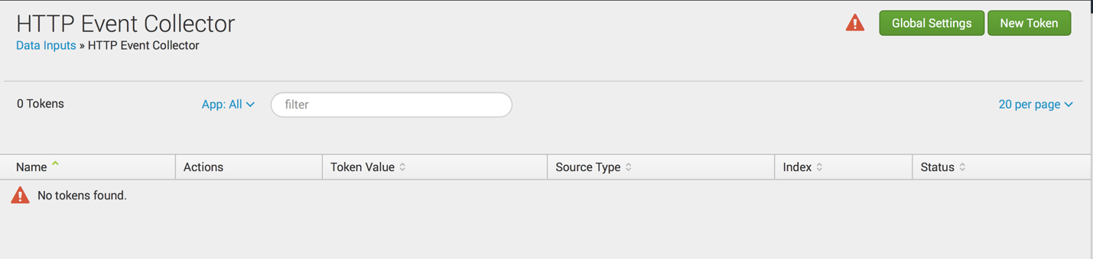

Enable HEC and leave all the other default settings:

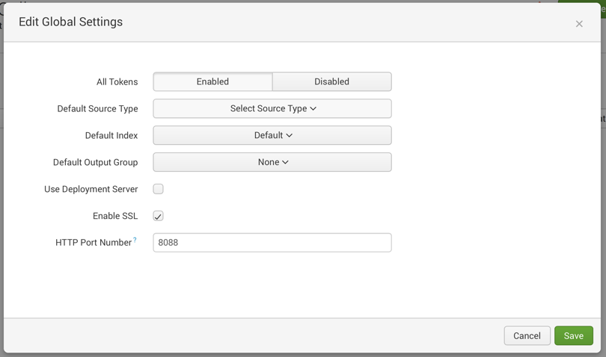

Click on Create New Token and name it “VPCFlowLogs” then click Next:

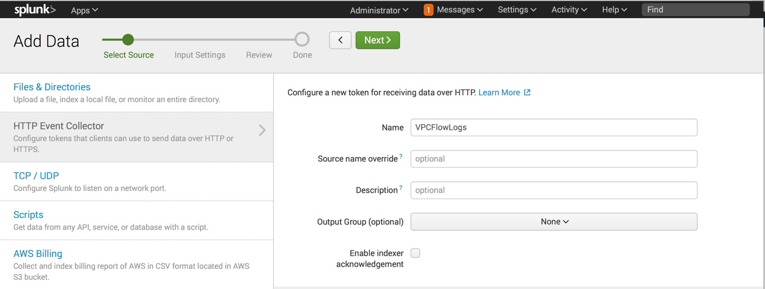

Select the sourcetype “aws:cloudwatch:vpcflow” leave all the settings to default; click Review:

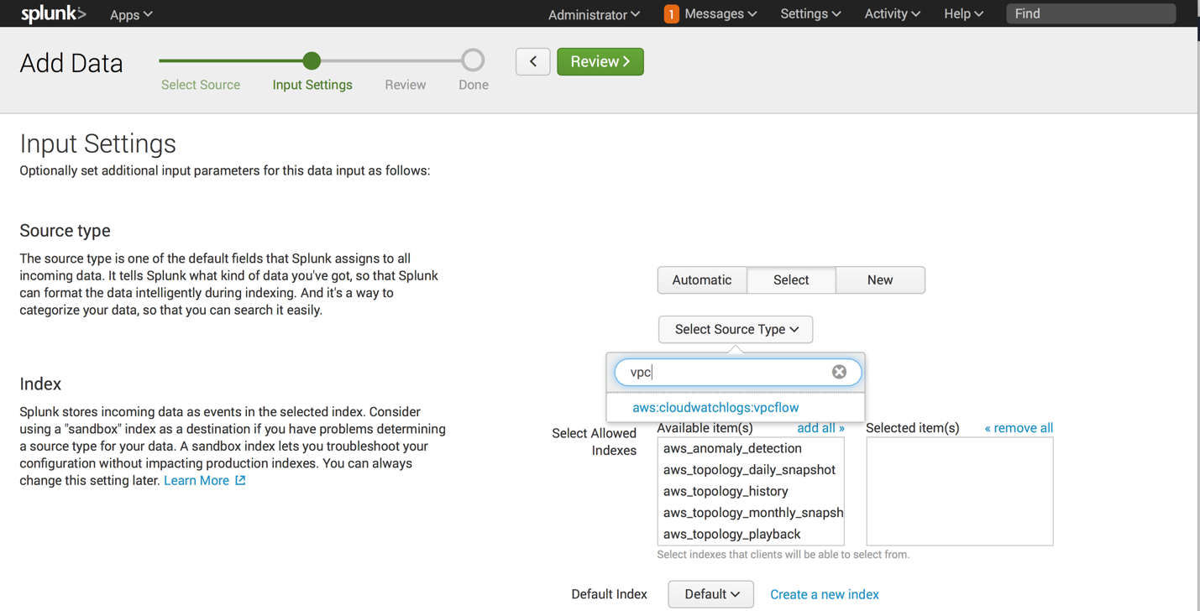

Review the settings then click “Submit”:

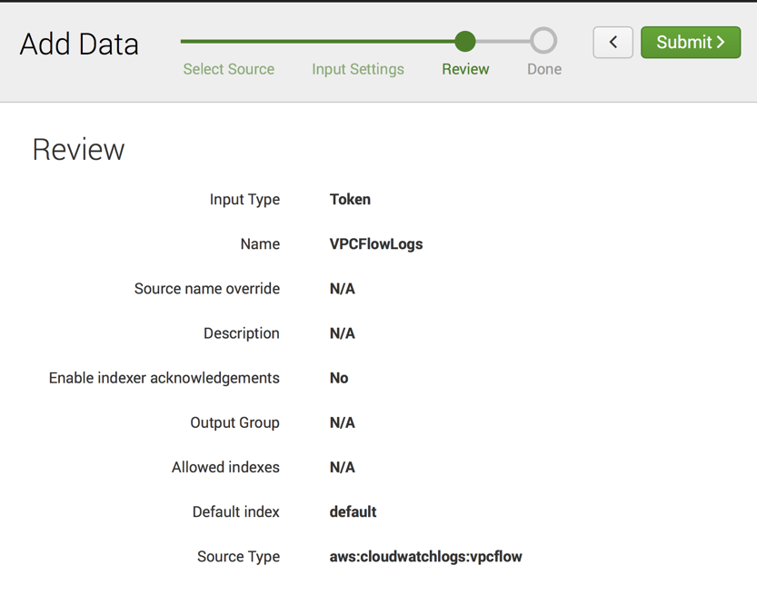

### Setup Lambda Function

This section will cover setting up a Lambda Function in AWS that will be used to send the VPC Flow Logs to Splunk using the HEC and the token we just created. Let’s start by opening the Lambda service in AWS:



Click on Get Started Now in Lambda:

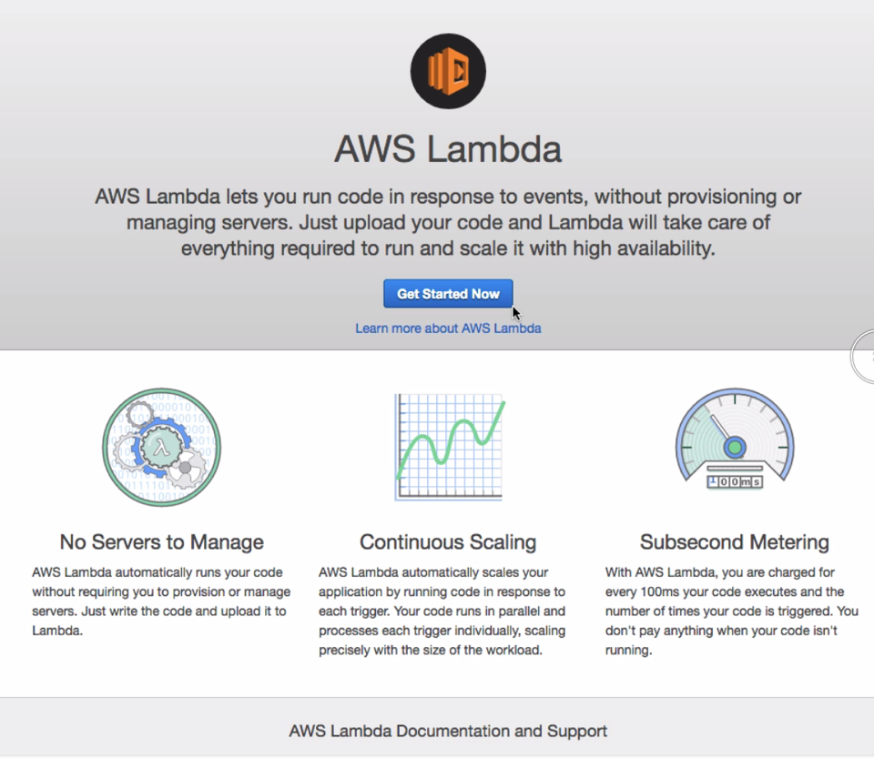

Click Create Function and then search the Blueprints for “Splunk”, select the “splunk-cloudwatch-logs-processor”:

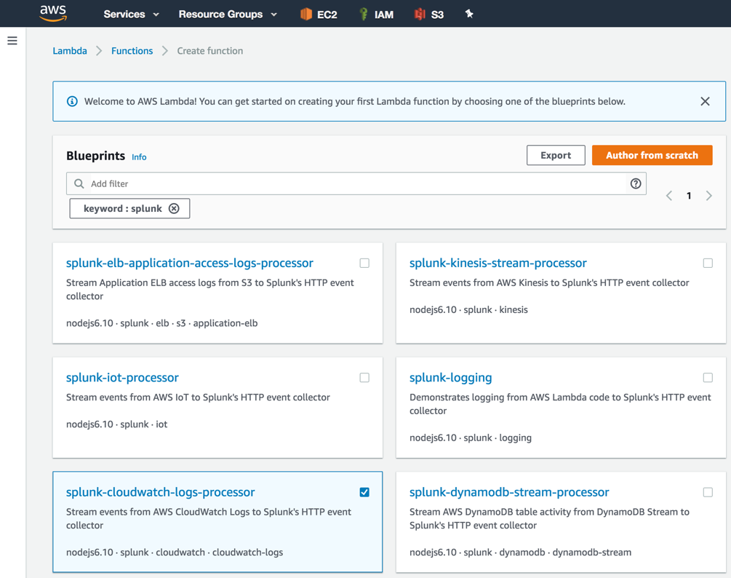

Give the function a name (SplunkVPCFlow) and select the execution role. If this is your first function, you will need to create the role, just select “Create a custom role” and follow the instructions:

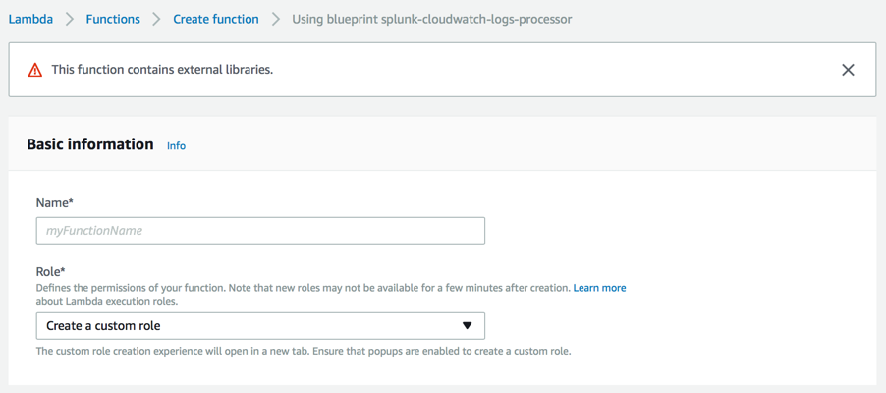

** A New tab will be created in your browser taking you to this IAM Role creation page **

In the IAM Role screen, click on Allow:

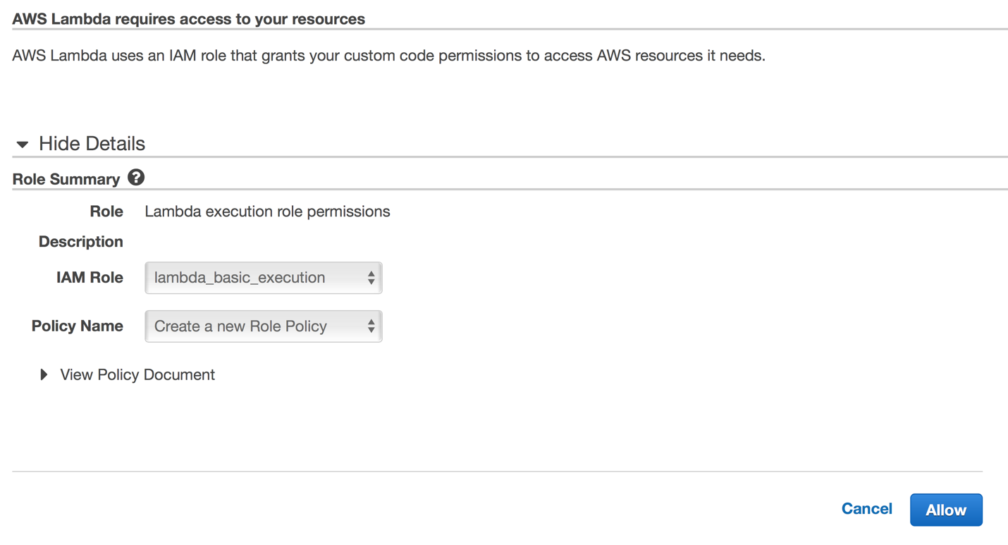

Once you click Allow, it will take you back to the function creation with the role, ‘lambda_basic_execution’ selected:

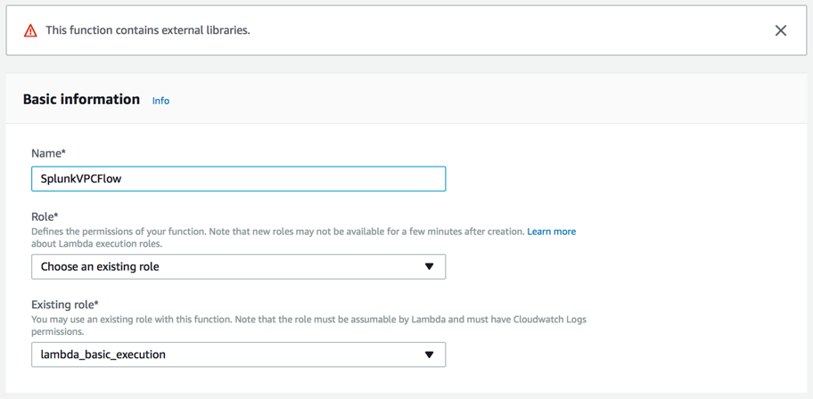

Under the ‘cloudwatch-logs’ select the VPCFlowLogs CloudWatch Log Group, type in “no filter” under Filter Name and enable the trigger. When a VPC Flow event is written to this cloudwatch group, it will execute the lambda function and send the event to Splunk:

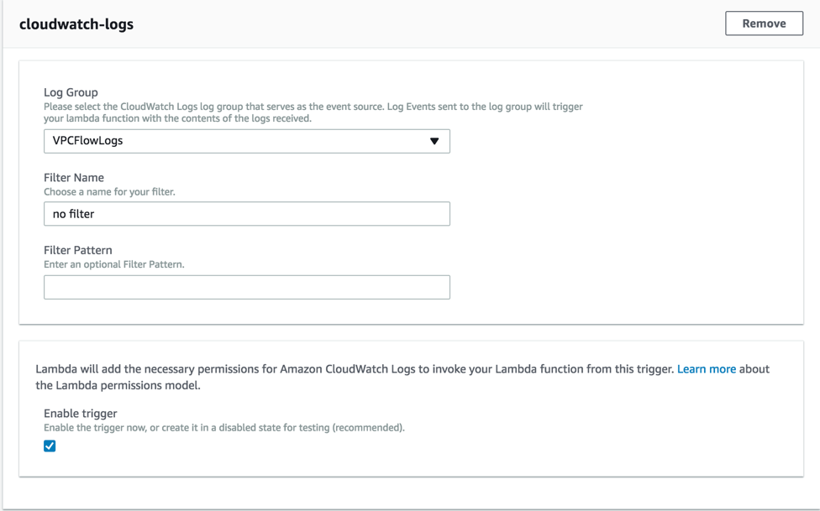

Lambda function code: Here you will need the URL of your Splunk instance and the HEC Token you just created:

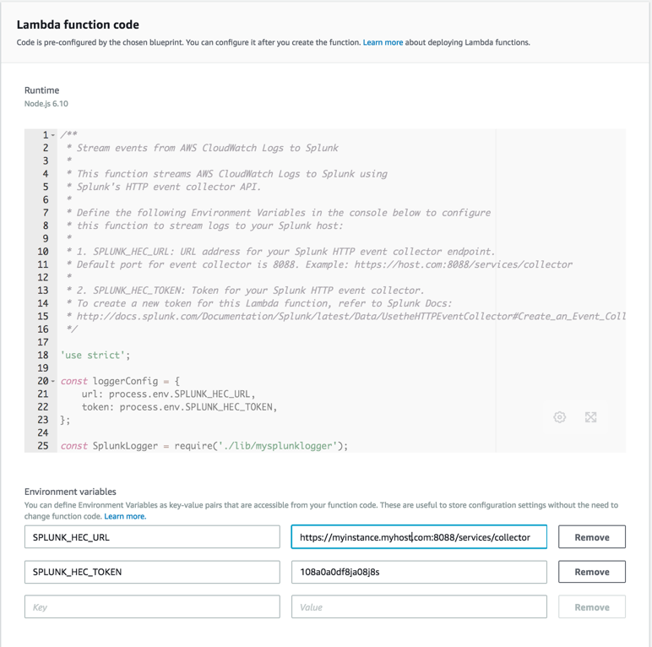For this instance, the URL should look like this: https://<your_ip>:8088/services/collector

Next, set the Token found in your Splunk instance. To find the token, log into your Splunk instance, go to *Settings -> Data Input -> HTTP Event Collector -> Copy the Token Value.*

Finally, click Create Function.

## Module 4 – Setting up Splunk App for AWS

This module will cover setting up the Splunk App and Add-on for AWS with your newly create instance. First, we will add the IAM Account information using the Access and Secret Key found in the **credentials.csv** file you downloaded. Next, we will use the EC2 role and attach it to the instance to show how Splunk can auto discover the credentials without having to manually input the Access and Secret key.

### Adding SplunkAccess User

Start by click on the Splunk Add-on for AWS from the home screen:

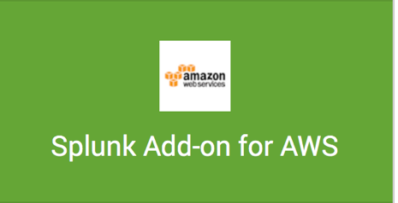

Click on the “Configuration” Tab:

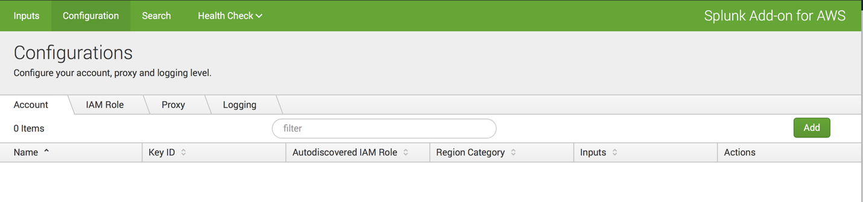

Notice there are no accounts associated with this instance, click on the “Add” button and add the SplunkAccess Account information:

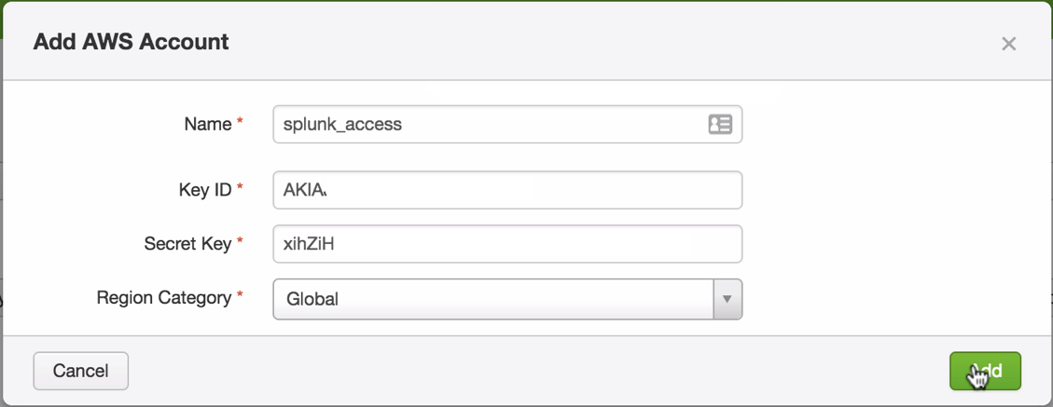

The Account show now show up in the console:

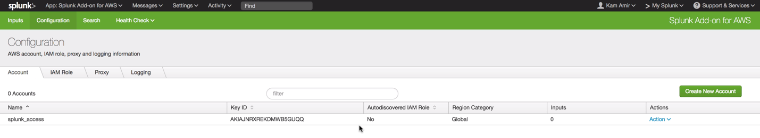

### Adding SplunkEC2Role

If we are deploying in an environment where Access and Secret keys are not used, one can attach a role to the instance and Splunk will auto discover the role with the associated policy. Start by going into your AWS Console and select your instance running the Splunk AWS Add-on.

Under Actions, select “Instance Settings” -> “Attach/Replace IAM Role”

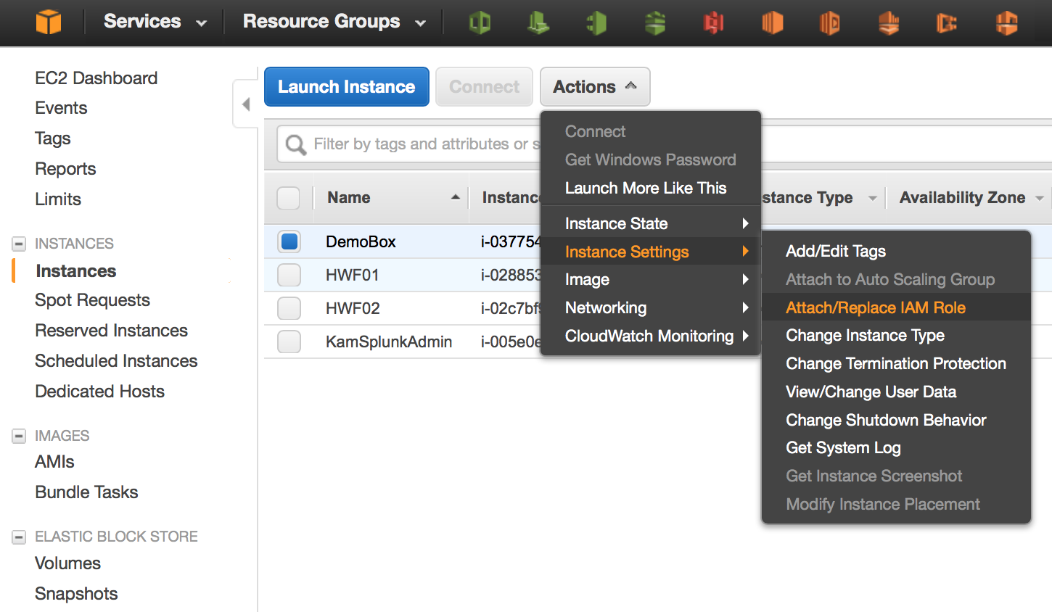

Now, select the SplunkEC2Role and attach it to the instance:

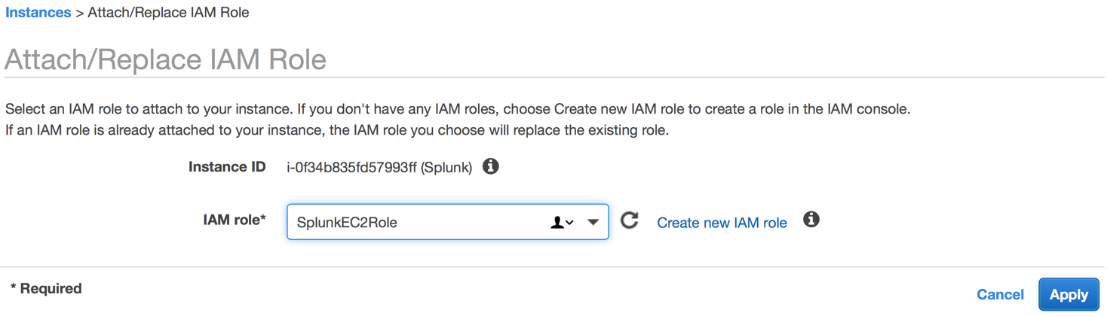

Go back to the Splunk AWS Add-on and click on Configuration, you will see the SplunkEC2Role was auto discovered:

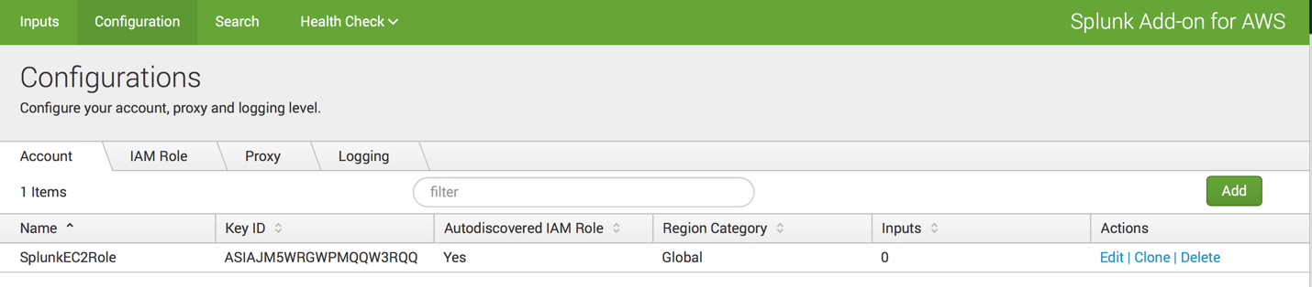

## Setting up AWS Config in Splunk

In the Splunk Add-on for AWS, click on Inputs and click on the “Create New Input” Button. In the dropdown menu, select Config->SQS Based S3:

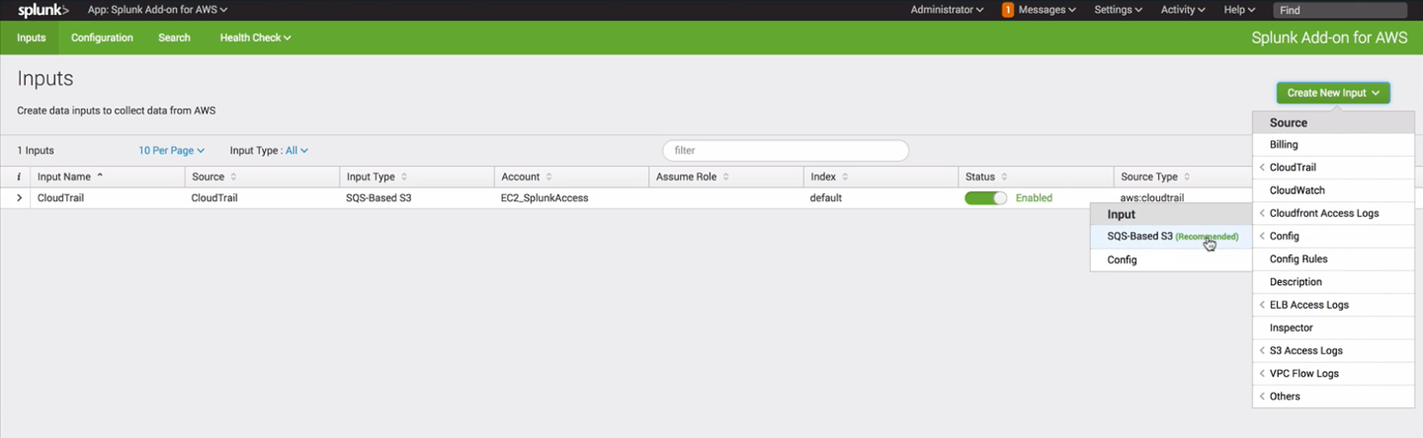

Under the Settings, name the input Config, select the region you are operating in and the select the AWS Config Queue (config-subscription):

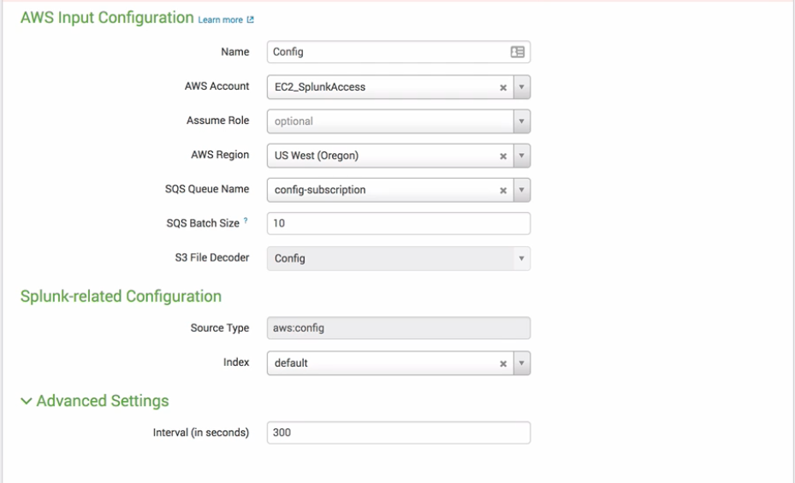

Leave all the default settings and click Submit.

## Setting up AWS Config Rules in Splunk

In the Splunk Add-on for AWS, click on Inputs and click on the “Create New Input” Button. In the dropdown menu, select Config Rules:

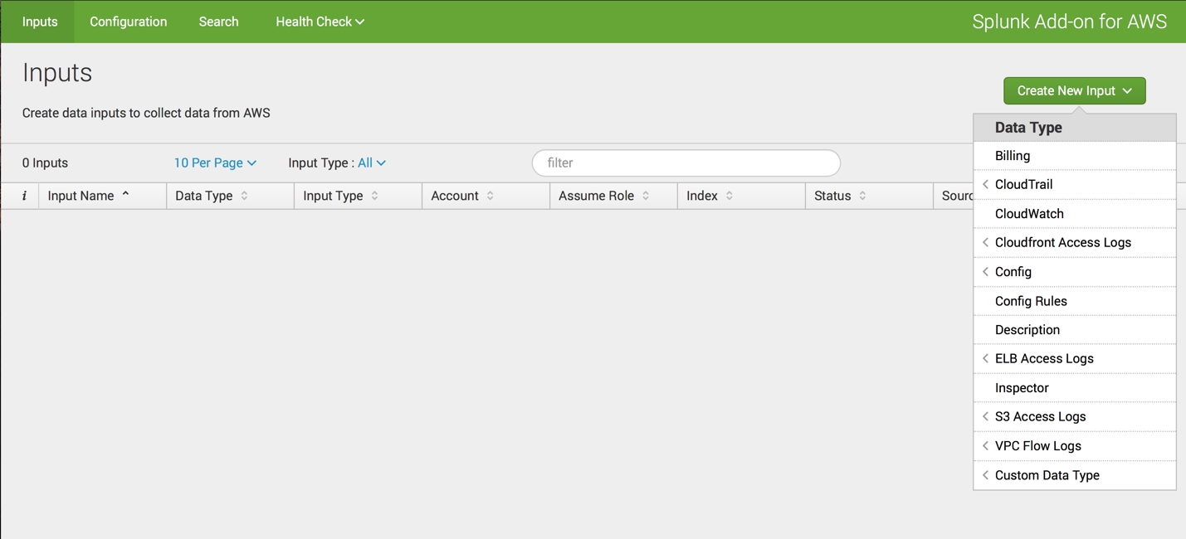

Select the AWS Account, then select the region you are using for your Cloud deployment:

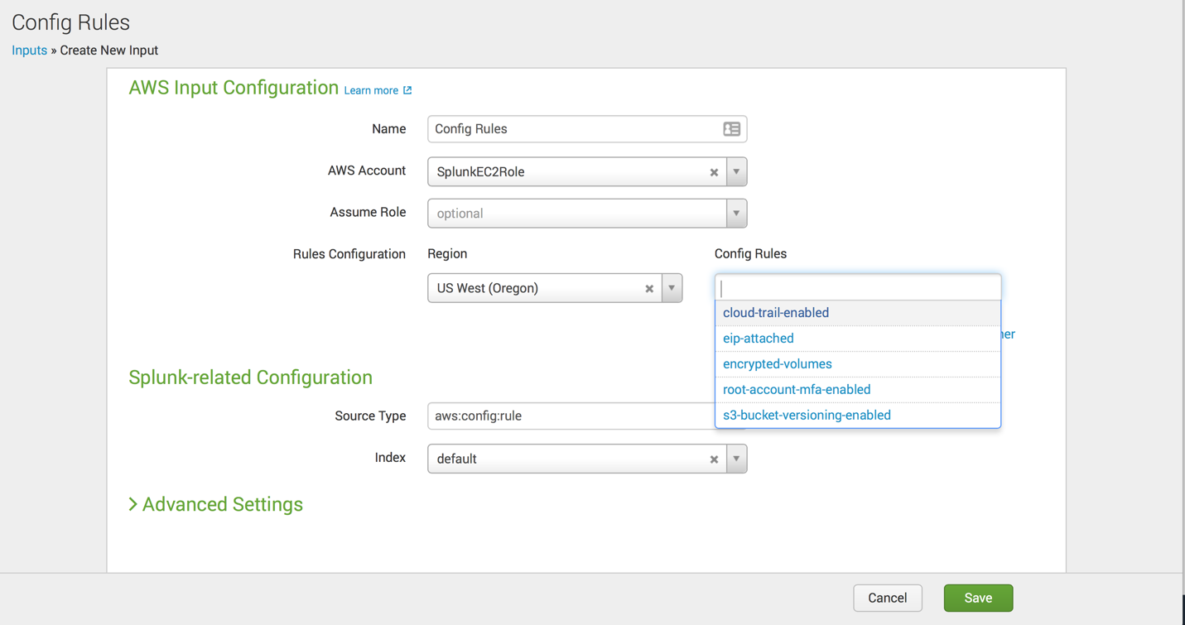

Select the rules you want collected in Splunk then click “Save.”

## Setting up AWS CloudWatch (metrics) in Splunk

In the Splunk Add-on for AWS, click on Inputs and click on the “Create New Input” Button. In the dropdown menu, select CloudWatch:



Give the input a name, CloudWatch and then select the AWS Account and finally select all the Regions you want to collect data from:

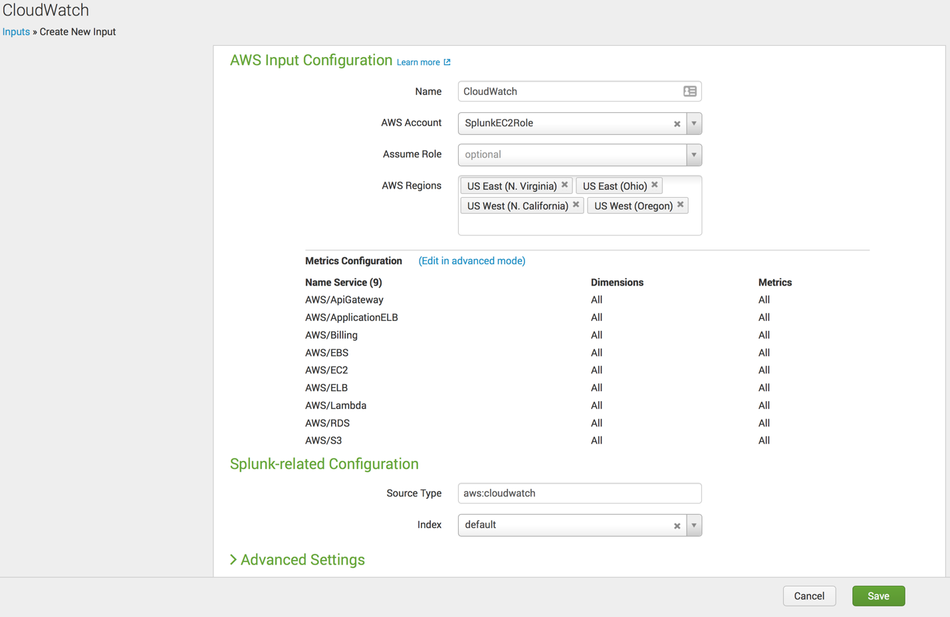

This will collect many services by default, but if you want to add more simply click the “Edit in advanced mode” and add the other services. Leave all the other settings as default and click “Save.”

## Setting up AWS CloudTrail in Splunk

In the Splunk Add-on for AWS, click on Inputs and click on the “Create New Input” Button. In the dropdown menu, select CloudTrail->SQS Based S3

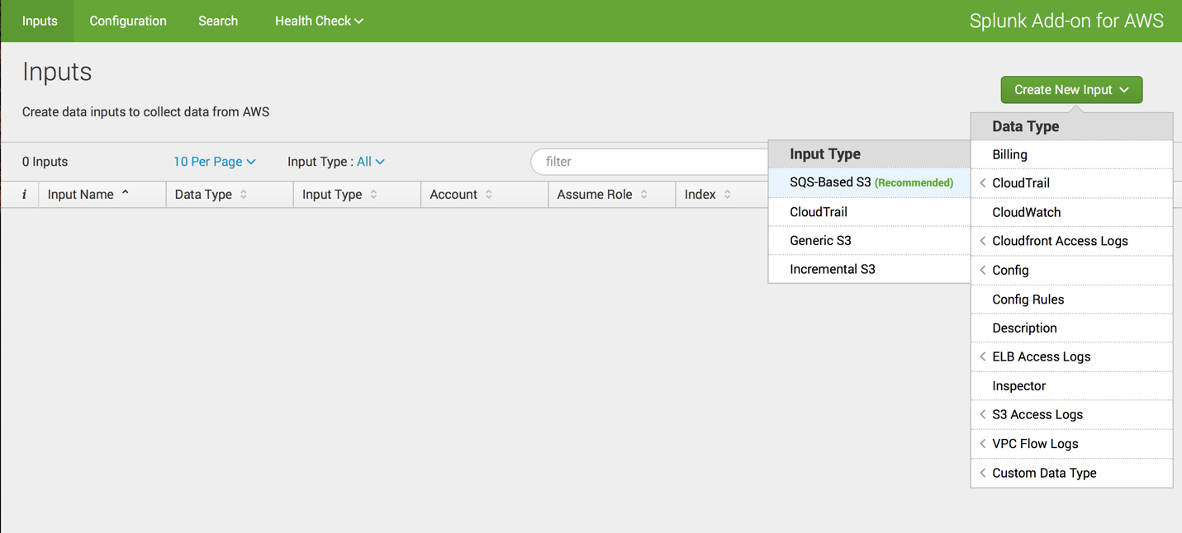

Name the input Cloudtrail, then select the AWS account, your default region and the cloudtrail SQS:

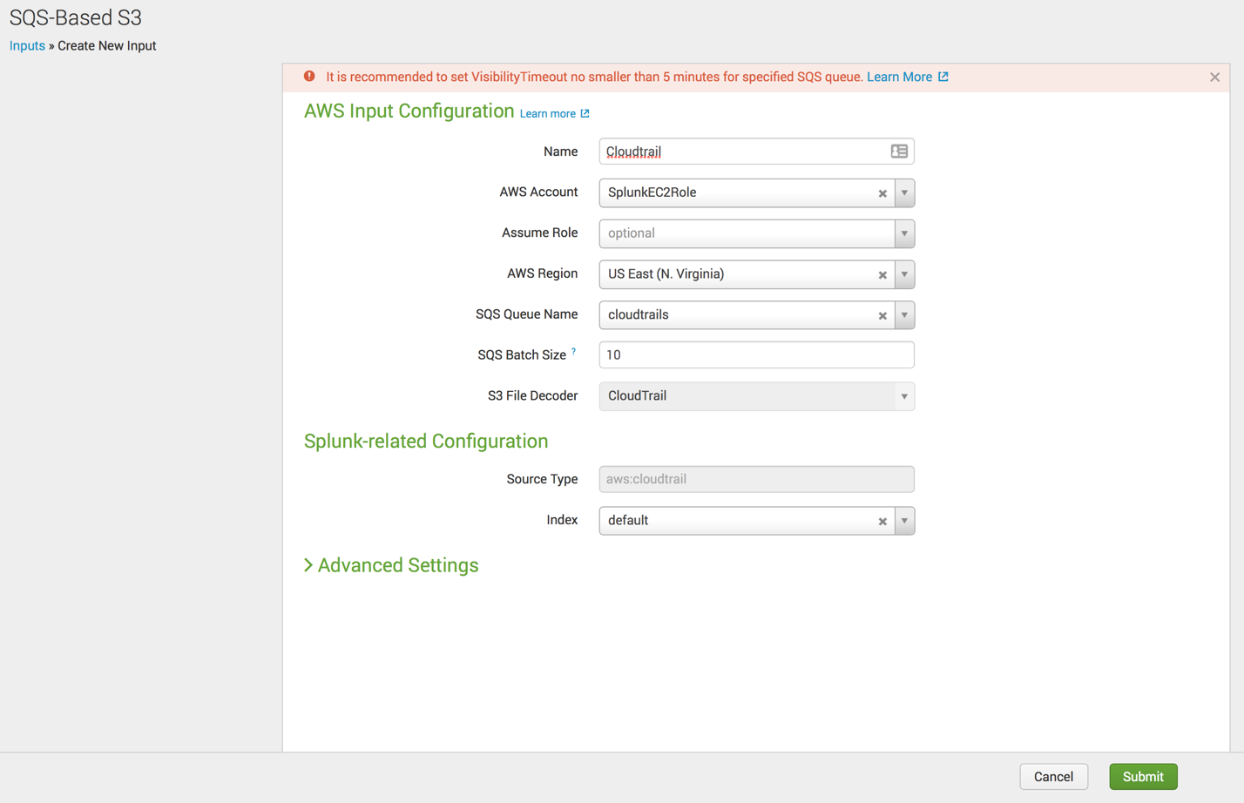

Leave all the defaults and click “Submit.”

## Setting up AWS Inspector in Splunk

In the Splunk Add-on for AWS, click on Inputs and click on the “Create New Input” Button. In the dropdown menu, select Inspector:



Name the input Inspector, then select the AWS account and the regions you want to collect from:

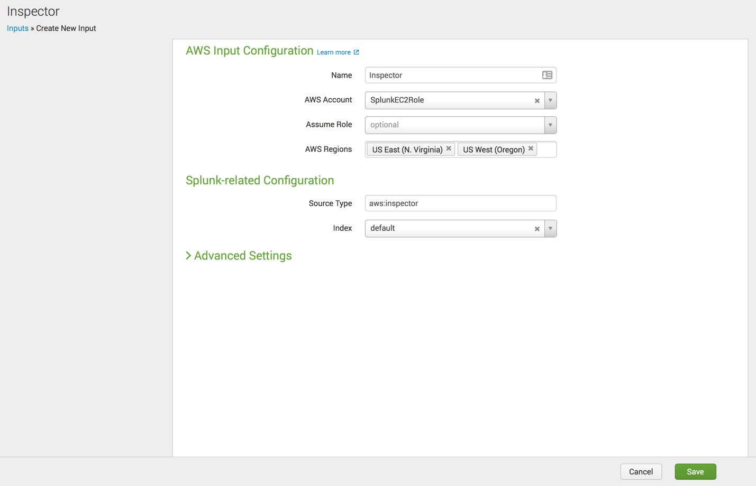

Leave all the defaults and click “Save.”

## Setting up AWS Description (metadata) in Splunk

In the Splunk Add-on for AWS, click on Inputs and click on the “Create New Input” Button. In the dropdown menu, select Description:



Name the input Description, select the AWS Account, and then select all the regions you want to collect data from:

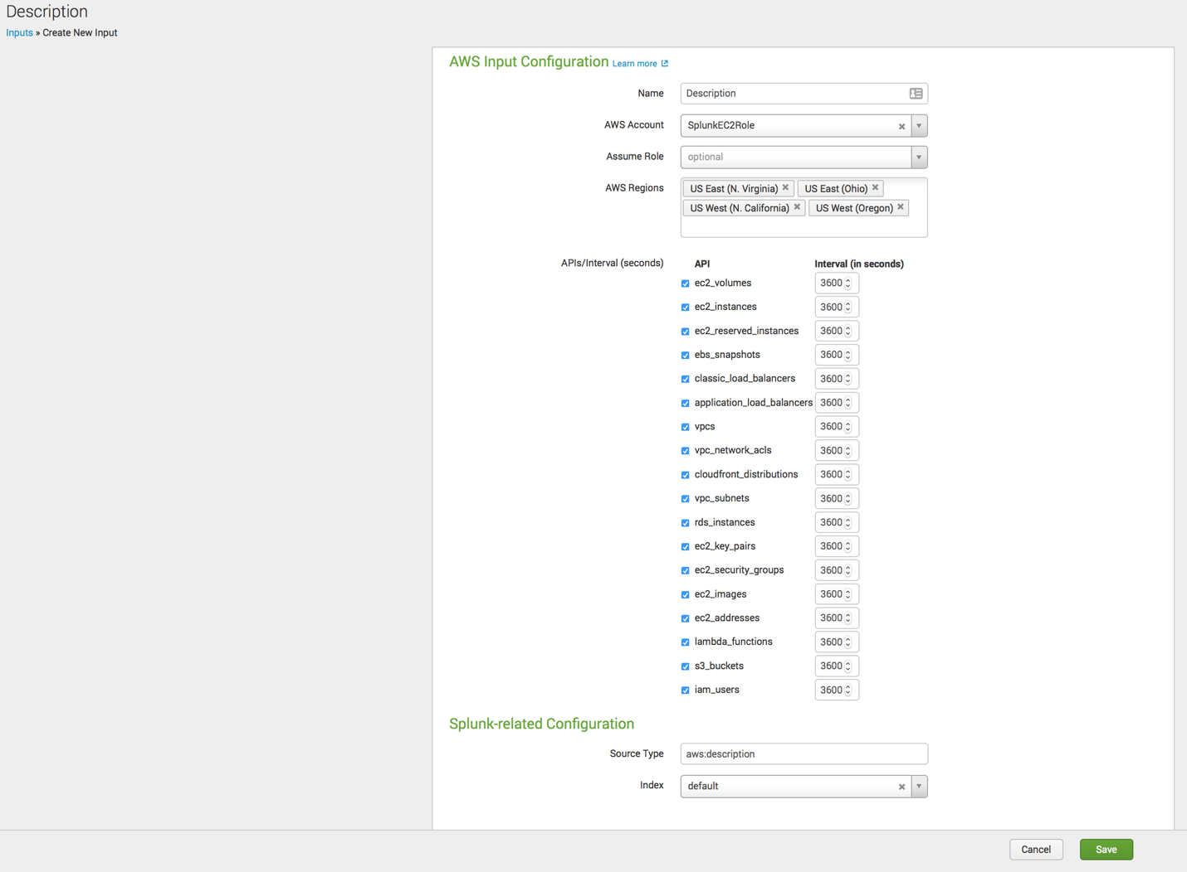

Leave all the defaults and click “Save.”

## Setting up AWS Billing in Splunk

In the Splunk Add-on for AWS, click on Inputs and click on the “Create New Input” Button. In the dropdown menu, select Billing:



Name the input Billing, select the AWS Account, the Billing S3 bucket, then leave all the default settings.

** Note, if you have a Splunk owned account, you will NOT be able to add this input. **

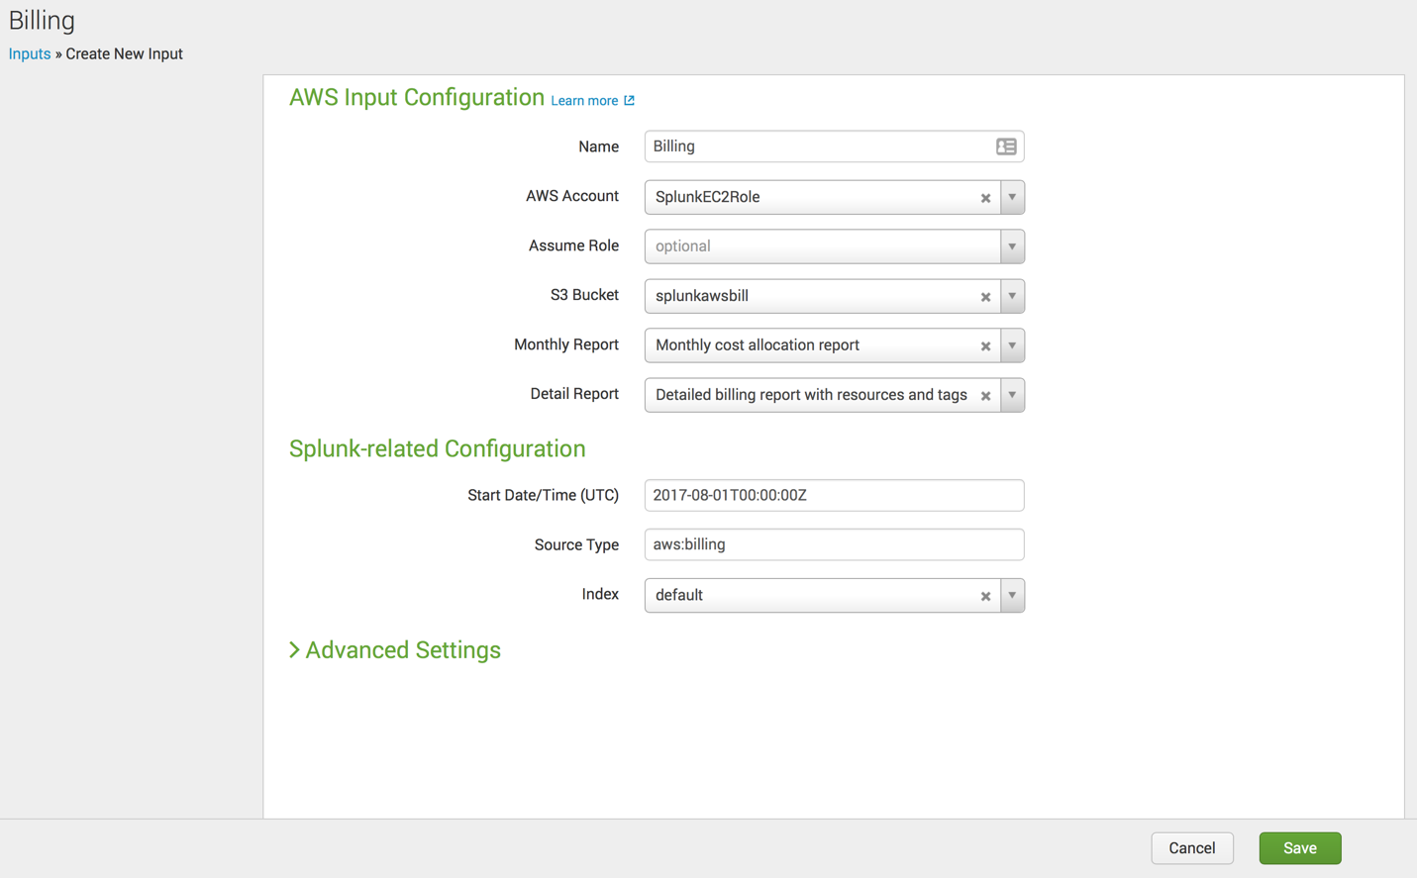

Leave all the defaults and click “Save.”

## Module 9 – Setting up Kinesis Firehose

## Module 5 - Troubleshooting

***Where’s my data?***

Generally, when a customer first tries to set up the App and Add-on, they run into permission issues for the AWS services, or improperly configured services. It is best to make sure to go over the permissions of either the IAM Account or EC2 Role that Splunk will be using to access the AWS data. Data being stored in S3 will require some additional testing to make sure Splunk can access the data in the S3 bucket.

First, check to see if there are any permission errors in the _internal index. The Health Dashboard on the AWS Add-on can also help narrow down the culprit for the missing data. The top issues are:

1) Permission to the Service – Validate by checking the _internal index : index=_internal sourcetype=aws:* permission* | stats count by sourcetype

2) Wrong AWS region – Make sure they have the service setup in the region they are using in the Add-on.

3) API Throttling – AWS protects it’s API’s by limiting the number of calls customers can make to their API’s. This is done to help keep up the performance of their system. Customers hitting these limits should consider using Lambda Functions or Kinesis Firehose to collect these data sources.

4) S3 bucket permission – Looking in the _internal index again can show if Splunk is having trouble accessing any specific S3 bucket.

***Why aren’t all my dashboards populating?***

Once the Splunk App and Add-on for AWS have been setup, customers tend to make changes to the default settings. These changes might have some adverse effects on the dashboards and summary indexes. First, they will create a new index and start sending their AWS data into this new index (e.g. aws or aws_data.) Updating the Search Macro will help fix this issue because the macro is what is powering the saved search which in turn is creating the summary indexes.

## Summary

After completing the steps of this course, you should have a fully configured AWS environment and a Splunk solution able to collect all the data AWS is generating.

* AWS Config (Configuration Information)
* AWS CloudTrail (API Calls)
* AWS CloudWatch Logs, specifically VPC Flow Logs
* AWS CloudWatch Metrics
* AWS Config Rules
* AWS Inspector
* AWS Description

While this solution can collect all the necessary data, there will be work needed to be done in order to make this into a production environment. For more information on how to set this up in a distributed Splunk deployment, please refer to this documentation link: <http://docs.splunk.com/Documentation/AWS/5.1.0/Installation/Installon-prem>

### Data Collection Estimates

Customers always want to know roughly how much data this app will generate and is the additional load worth the potential expense. From the behavior of customers on Splunk Cloud around the Splunk App for AWS, most customers collect less than 20GB/day. As they mature with their workloads in AWS, the volume tends to go higher and plateau around 100-200GB/day (depending on the complexity of their deployment.) Only a few customers ever eclipse the 1TB of AWS data, but it is possible.

### Breakdown of Data Volumes by sourcetype in AWS

At first, CloudWatch Logs, specifically VPC Flow logs are the highest volume data source. CloudTrail then becomes the second highest volume data source. Once customers start to send their application logs into Kinesis streams, that’s when this source takes over and becomes the single largest source of data volume.

## Appendix

This section will go over legacy setup steps that are not used during the lab.

### Splunk Access Account

The Splunk Access user will have a limited access to your AWS deployment and will only be used to access the services it has access to via the policy we will attach to it. First, open the Users under IAM, and click “Add user”:

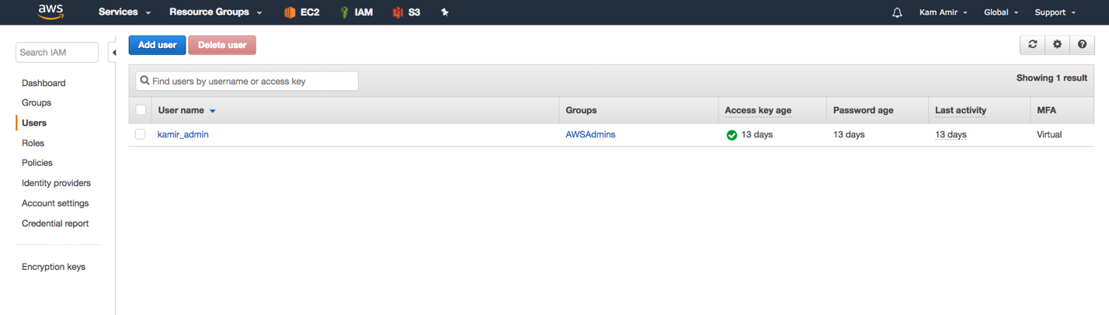

Name the user, I suggest ‘splunk_access’ and grant it “Programmatic access”:

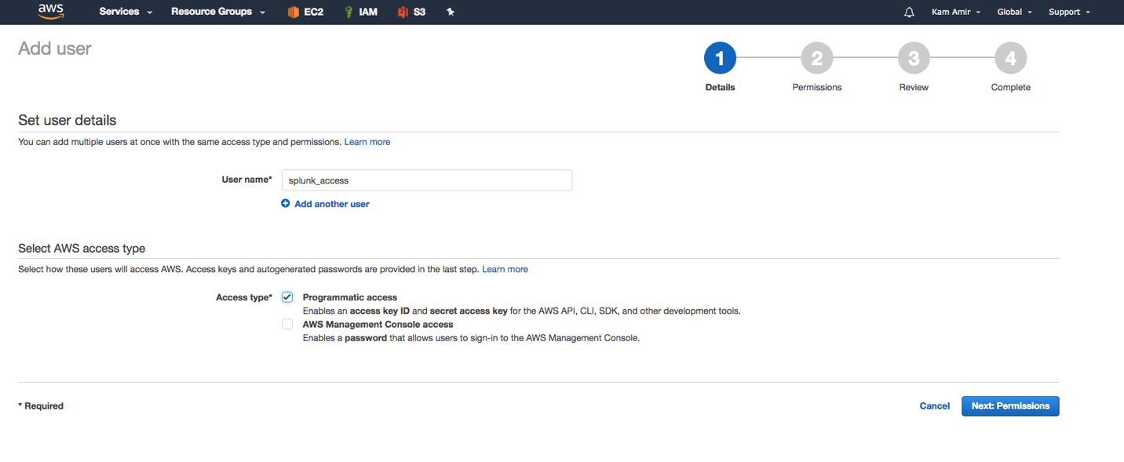

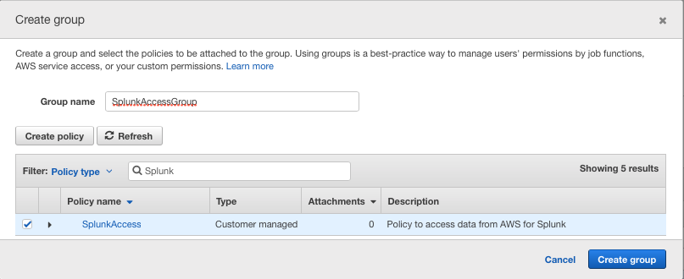 Now, you will create a new group and attach the newly created SplunkAccess Policy:

Search for Splunk and select the newly created SplunkAccess policy

After creating the group, click on “Next: Review”:

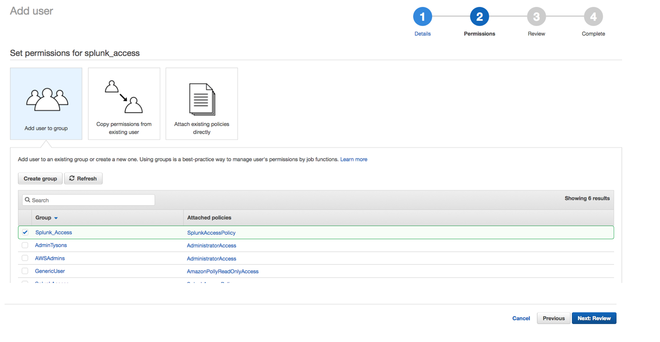

Finally, click on Create User:

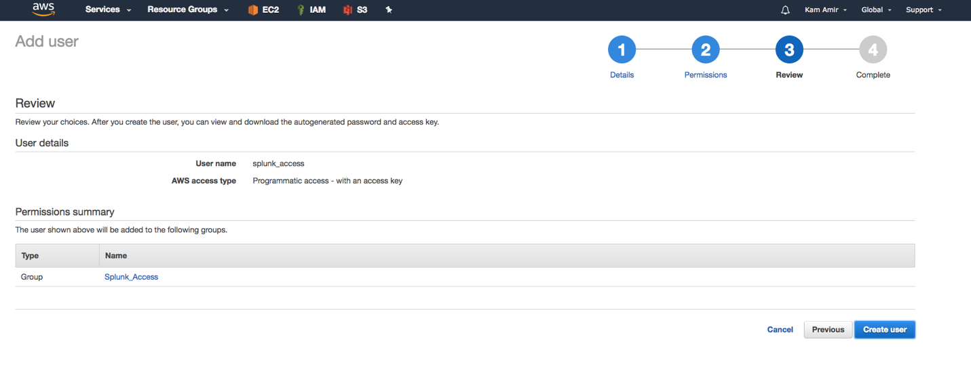

Don’t forget to download the credentials.csv file:

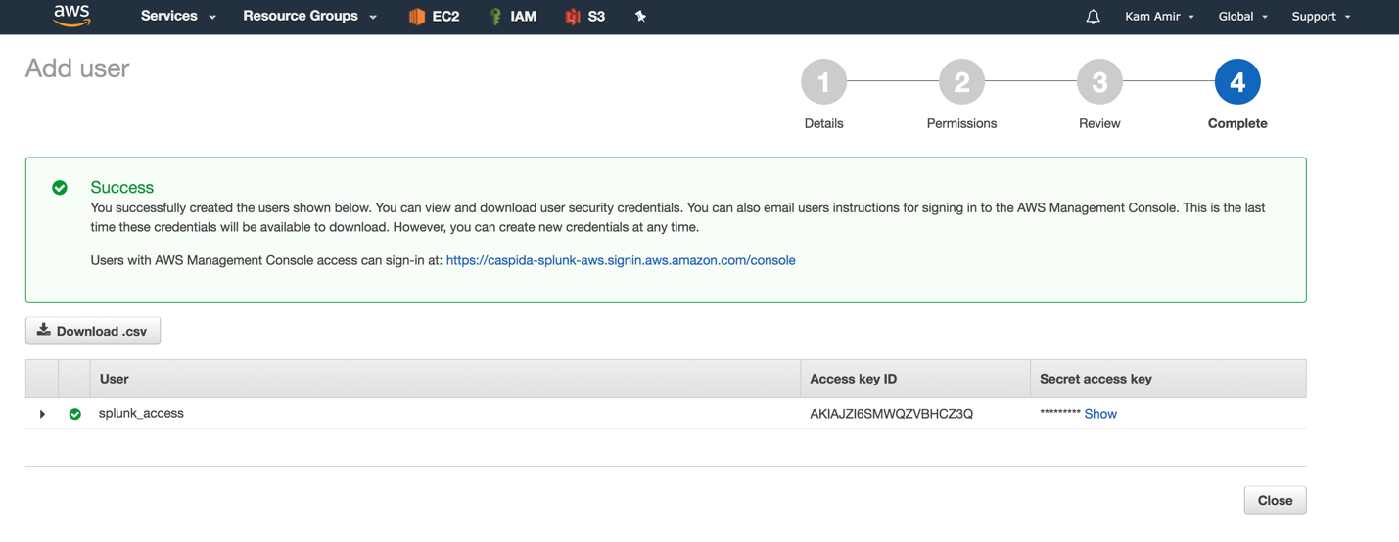

##### AssumeRole for Multiple Sub-Accounts:

This scenario is relevant when a customer has multiple sub-accounts and would like to use a primary account to collect the data from the sub-accounts. First, the sub-accounts will establish a role that has a trust relationship in place with the primary account. Then, the IAM user in the primary account will be added to the role which is trusted by the sub-accounts. In the Add-On, using the AssumRole feature, the account will be able to collect data from the sub-accounts.

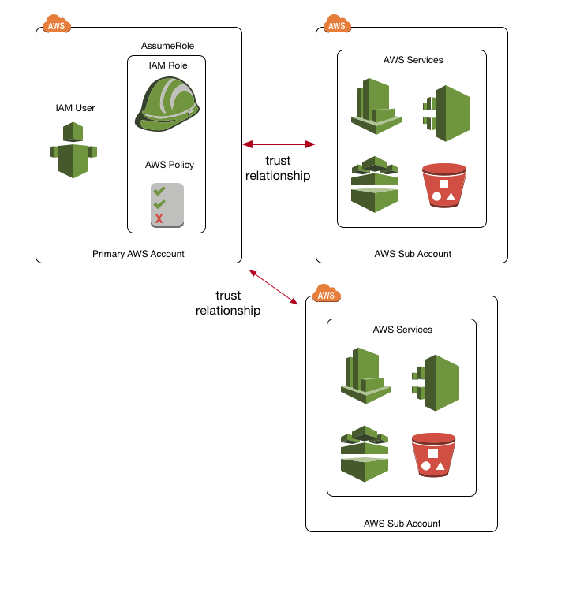

This portion of the lab will require TWO AWS accounts to setup. Please create a dummy account with a personal email and terminate it once you’ve completed the lab.

The process to setup a master account with access across multiple sub-accounts is done under the IAM Roles and establishing a trust relationship. First in the sub-account, open IAM and navigate to the Roles section:

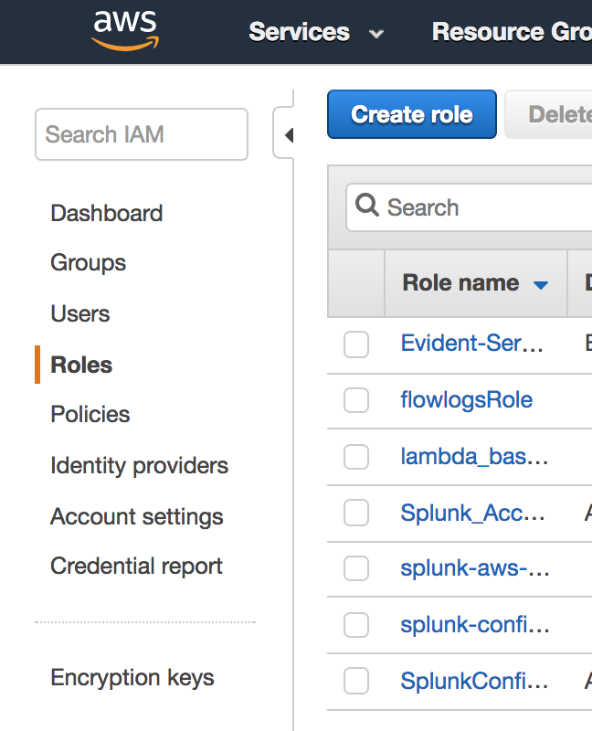

Now create a new role called “cross-account-splunk-access-roll” with the entity type being “Another AWS account:”

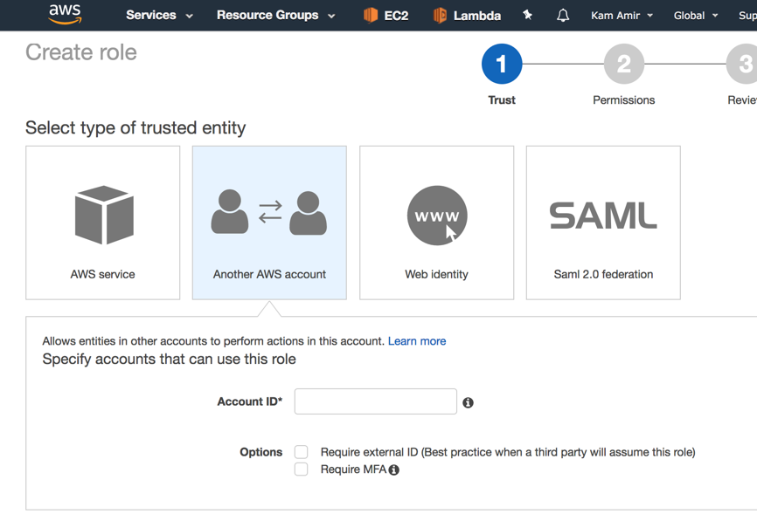

Under Account ID* enter in the **Primary AWS** account that will be ACCESSING this sub-account and leave the two options **unchecked**. Click Next: Permissions

Assuming you have already create the Splunk Access policy in this account, simply find it and attach it to this role, then click Next:Review:

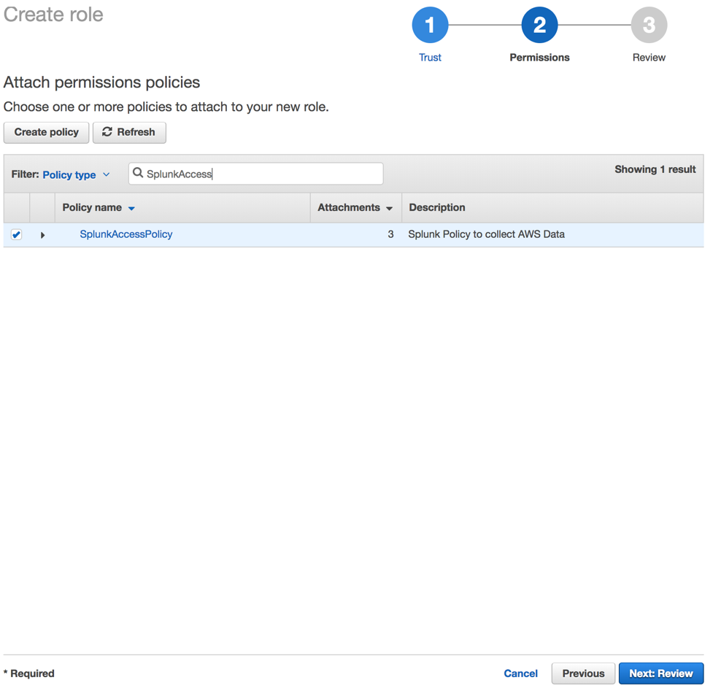

Give this new role a name and a short description, then click **Create role**:

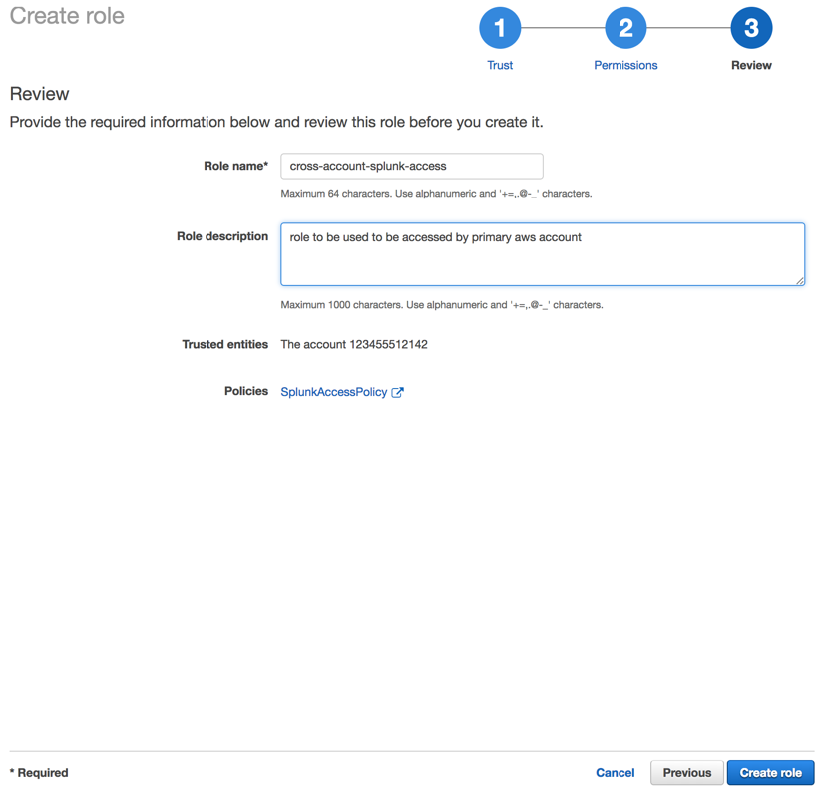

Once this role is created, go to Splunk Add-on for AWS -> Configurations -> IAM Role and click Add. Then, take the role ARN and set it up in the Splunk Add-on for AWS as an IAM role.

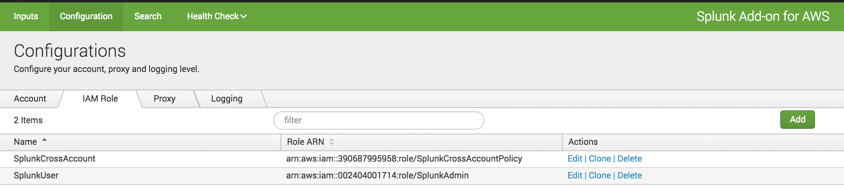

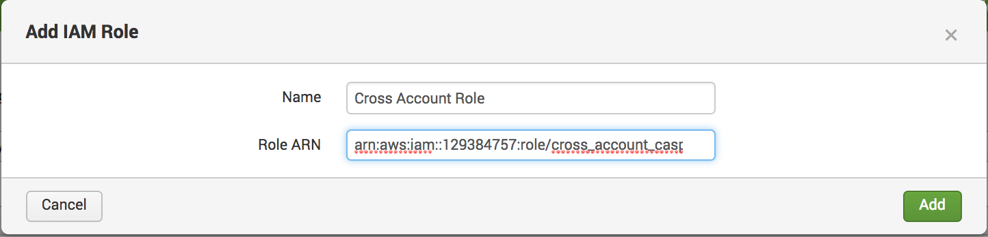

Use the AssumeRole field in any of the inputs to gain access to the sub-account AWS services.